Railway Management System (RMS) Requirements Specification

Version 1.0

March 8th, 2025

**

**Table of Contents**

**1. Executive Summary 2**

**1.1 Project Overview 3**

**2. Product/Service Description 3**

**2.1 Product Context 3**

**2.2 User Characteristics 3**

**2.3 Assumptions 3**

**2.4 Constraints Dependencies 3**

**3. Requirements 3**

**3.1 Functional Requirements 4**

3.2 Non-Functional Requirements 5

**3.2.1 Product Requirements 5**

3.2.1.1 Usability Requirements 5

3.2.1.2 Performance Requirements 5

3.2.1.3 Availability 6

3.2.1.4 Security 6

3.2.2 Organizational Requirements 6

3.2.3 External Requirements 6

**4. User Scenarios/Use Cases 6**

**5. Diagrams 7**

**6. Design Patterns 7**

**7. Appendix. 7**

**Organizing the Requirements 7**

# Executive Summary

## Project Overview

This project seeks to model and design a management system that is capable of automating and streamlining the operations of a given railway network, ensuring quicker operations, precise commands, higher security, and general improvements in user experience.

# ***Product/Service Description***

The Railway Management System is designed to modernize and optimize the operations of railway networks by addressing the core challenges of managing trains, passengers, schedules, and maintenance, ultimately improving efficiency, safety, and customer satisfaction across the entire transportation ecosystem.

## Product Context

RMS does not have to necessarily be a standalone product. During development, we keep in mind functionalities that the system may gain from the use of other parent or child systems. For example, the system may need to serve as a smaller cog in a local public transportation management system in regards to train traffic control (parent system), or it might interact with systems such as embedded systems in the trains and stations to communicate availability (child system). The system should also need to be aware of other neighbouring railway systems that fall outside of its jurisdiction.

## User Characteristics

* Station Managers
* Train and Station Personnel
* Passengers
* Traffic Manager
* Railway and Train Maintenance (External Maintenance)
* Admin

## Assumptions

An assumption is made that the system "owns" and directly controls a fleet of trains. This simplifies the design by reducing the complexity involved in interacting with other external systems or organizations. Under this assumption, the system has full access to operational data, maintenance schedules, and scheduling control for the entire fleet.

## Constraints and Dependencies

In the design and development of the Railway Management System (RMS), we must consider several **constraints** and **dependencies** to ensure that our system operates effectively and meets the required standards. Some examples are:

**1.Access, management and security**

* **Access Control**: The system must implement strict access control mechanisms to ensure that only authorized users (e.g., administrators, maintenance personnel, and passengers) can access sensitive information. Role-based access control will be used to enforce security policies.
* **Data Security**: The system must adhere to industry-standard encryption protocols (e.g., AES, SSL/TLS) to protect passenger data, payment information, and operational data both in transit and at rest.

**2.Non-stop operation**

* **Availability:** The system must be highly available and capable of operating 24/7, ensuring no downtime during peak travel times or maintenance windows. High availability solutions like load balancing, failover systems, and backup servers will be implemented.

#### 3. Record Keeping

* **Data Retention**: The system must maintain historical records of train schedules, passenger transactions, maintenance logs, and other operational data for a specified retention period, as mandated by regulatory requirements and internal policies.

#### 4. Scalability

* **User Load**: The system must be scalable to handle increased user traffic, especially during peak times (e.g., holiday travel, rush hours). This includes passenger reservations, ticket sales, and administrative access.
* **Data Volume**: As the railway network expands, the system must scale to accommodate increasing amounts of operational data, such as train schedules, maintenance records, and passenger transactions.

#### 5. Budget and Resource Constraints

* **Budget Limitations**: The design, development, and deployment of the system must adhere to budget constraints, which may limit the choice of technologies, features, and scale of implementation.

#### 6. Time Sensitivity and Real-Time Data

* **Real-Time Updates**: The system must provide real-time updates on train schedules, delays, cancellations, and seat availability to passengers, as well as to the administrative team. This requires low-latency data processing and communication protocols.
* **Synchronization**: Time synchronization across multiple components (trains, stations, servers) is critical to ensure consistent and accurate data for scheduling and reporting purposes.

# **Requirements**

## *Functional Requirements* Naming Key

#### Actors

## S = System

## TM = Traffic Manager

## SM = Station Manager

## P = Passenger

## E = Employee

## M = Manager

## U = User (All Users)

## A = Admin

## Requirement Types

## MNG = Management (Tracks, Scheduling, etc.)

## INT = Interoperability (External Systems)

## TRK = Tracking (Stations, Railways, Trains, etc.)

## SCH = Scheduling & Timetables

## PER = Personnel & Passenger Management

## TKT = Ticketing (Booking, Cancellation, Loyalty)

## PAY = Payment Processing

## NOT = Notifications & Updates

## WRK = Employee Work & Tasks

## VIW = Information Access & Viewing

## ALR = Alerts & Emergency Responses

## SVC = Passenger Services (Accessibility, Special Requests)

## CAP = Capacity Management (Prevent Overbooking)

## AUTH = Authentication & Logging (Login/Logout)

## FIN = Financial Tracking & Reporting

## LOG = System Logging & Operations

## ADM = Admin-Specific Controls

| **Req#** | **Requirement** | **Comments** | **Priority** | **Date Rvwd** | **SME Reviewed / Approved** |
| --- | --- | --- | --- | --- | --- |
| **TM_MNG_01** | The system must track and update the status, availability, and condition of constructed tracks under management. | General geographic mapping | 1 |  |  |
| **S_INT_02** | System needs to be able to interact with other external railway systems outside of its jurisdiction | Interaction in this case involves keeping track of trains going from and to, closed railways and stations. | 1 |  |  |
| **S_TRK_03** | The system needs to be able to keep track of its own stations availability and condition | Conditions: onAlert, fullCapacity, underMaintenance.  More conditions TBD when other edge cases present themselves. | 1 |  |  |
| **S_TRK_04** | The system must track railway availability and condition to ensure safe and efficient train operations. | Conditions: onAlert, underMaintenance, occupied.  More conditions TBD when other edge cases present themselves. | 1 |  |  |
| **S_TRK_05** | The system must maintain accurate data on train car availability and condition for scheduling and maintenance. | Conditions: onAlert, underMaintenance, inUse, outsideBounds  More conditions TBD when other edge cases present themselves | 1 |  |  |
| **S_SCH_06** | The system must keep an updated schedule of trains and their specific itineraries to ensure proper route planning. | Keep track of both time and locations. | 1 |  |  |
| **S_PER_07** | The system must monitor human personnel availability and condition to ensure operational efficiency and workforce management. | Conditions: onLeave, onStandby, busy, onAlert  More conditions TBD when other edge cases present themselves | 1 |  |  |
| **S_PER_08** | The system must securely store and manage passenger information for ticketing, travel records, and customer service. | *Passenger information management must comply with data security and privacy regulations* | 1 |  |  |
| **TM_SCH_09** | The Traffic Manager must be able to create, update, and delete schedules for trains under their jurisdiction. |  | 1 |  |  |
| **SM_PER_10** | The Station Manager must be able to allocate human personnel to complete tasks on stations under their jurisdiction. |  | 1 |  |  |
| **TM_VIW_11** | The Traffic Manager must be able to view train information, station information, and track information. |  | 1 |  |  |
| **S_ERR_12** | The system must prevent Traffic Managers from making critical scheduling or operational errors using validation checks | Main errors include:  Routing through stations and tracks under repair or under alert  Causing train collisions on tracks | 1 |  |  |
| **SM_PER_13** | The Station Manager needs to be able to access personnel information. |  | 1 |  |  |
| **SM_SCH_14** | The Station Manager needs to be able to view train schedules under his jurisdiction. |  | 1 |  |  |
| **TM_VIW_15** | The Traffic Manager needs to be able to view the location of every train in real time |  | 1 |  |  |
| **SM_PER_16** | The Station Manager must have controlled access to passenger details while ensuring data privacy. |  | 1 |  |  |
| **P_TKT_17** | Passengers are able to book tickets for trains at an available time, with specifications such as class or sleep accommodation |  | 1 |  |  |
| **P_VIW_18** | Passengers are able to view train information |  | 1 |  |  |
| **P_TKT_19** | Passengers are able to cancel their reservations within a reasonable timeframe | Timeframe TBD | 1 |  |  |
| **S_PAY_20** | System must process payment for the booking of a ticket either using card or cash on the ticket booths |  | 1 |  |  |
| **S_NOT_21** | System must notify all users about changes in the time table according to their jurisdiction. |  | 1 |  |  |
| **S_NOT_22** | System must notify External Maintenance on scheduled maintenance checks |  | 1 |  |  |
| **E_WRK_23** | Employees should be able to log their hours into the system | Logged hours are calculated from account sign in when starting the shift and log out at the end of the shift. | 1 |  |  |
| **E_WRK_24** | Employees should be able to check specific tasks issued to them from the Station Manager. |  | 2 |  |  |
| **SM_WRK_25** | Station Managers should be able to send specific tasks to Employees |  | 2 |  |  |
| **SM_WRK_25** | All users must be able to see their personal information |  | 2 |  |  |
| **S_ALR_27** | System must be able to detect Alert sensors on railways, trains, maintenance centers, train depots and stations |  | 2 |  |  |
| **S_ALR_28** | System must notify the correct user for the specific alerts | Railway and Train alerts -> Traffic Manager  Station Alert -> Station Manager  Train Depots, maintenance Centers -> External Maintenance | 2 |  |  |
| **M_ALR_29** | Managers are allowed to call alerts on their own |  | 2 |  |  |
| **P_SVC_30** | Passengers can choose to call for accessibility services | “wheelchair accommodation, blindness accommodation, etc” | 3 |  |  |
| **P_TKT_31** | Passengers can opt into loyalty programs or alternate payment methods |  | 3 |  |  |
| **S_CAP_32** | System must observe train capacity to eliminate overbooking |  | 2 |  |  |
| **SM_ALR_33** | Station Managers are allowed to alert passengers to any of their alerts |  | 2 |  |  |
| **U_AUTH_34** | All users must have login logout functionality |  | 1 |  |  |
| **S_FIN_35** | The system must keep track of expenses and profit. |  | 1 |  |  |
| **SM_FIN_36** | Station Managers are able to check station revenue and expenses |  | 1 |  |  |
| **S_FIN_37** | The system must be able to generate detailed reports on revenue and expenses. |  | 1 |  |  |
| **S_LOG_38** | The system must keep track of all operations done in a specified timeframe |  | 1 |  |  |
| **S_SCH_39** | The system must keep track of the schedule of everything within a specific timeframe |  | 1 |  |  |
| **E_WRK_40** | Employees may request a shift change or time off |  | 3 |  |  |
| **A_VIW_41** | An admin user is allowed to view all info on the system |  | 1 |  |  |
| **A_ADM_42** | An admin user is allowed to access all functionalities of the system, including other users |  | 1 |  |  |

## *Non-Functional Requirements*

**Performance requirements:**

**1.System response time :**

* The system must respond to user requests, including ticket bookings, schedule lookups, and other operations ,within 4 seconds under typical operational conditions.

**2. Scalability:**

* The system must support a minimum of 100 concurrent users without performance degradation, ensuring it can handle seasonal or event-based traffic spikes.

3.**Data Processing Efficiency:**

* The system must be capable of processing large data sets (e.g., real-time train schedules, passenger data) within 3 minutes to facilitate timely decision-making.

**Security requirements :**

4.**Data Encryption:**

* All sensitive data, such as passenger details, payment information, and personal records, must be encrypted at rest and in transit using AES-256(Advanced Encryption Standard with a 256-bit key) encryption.

5. **Authentication and Authorization**

* The system must implement multi-factor authentication (MFA) for all users and enforce role-based access control (RBAC) to restrict sensitive operations based on user roles.

6. **Data Integrity**

* The system must ensure that data is accurate, complete, and unaltered by unauthorized users. All data modifications should be logged with timestamps and user identifiers.

**7.Activity Log**

* The system must maintain an audit trail of all critical operations, including user logins, data modifications, and system configurations, with logs retained securely for at least 12 months.

### 

### 

### 

### 

### Usability Requirements:

**8.User Interface (UI) Design**

* The system must feature an intuitive, user-friendly interface for all user types (e.g., passengers, station staff, administrators), minimizing the need for extensive training.

9. **Cross-Platform Compatibility**

* The system must be fully responsive, providing an optimal user experience on both desktop and mobile platforms, supporting the major browsers and mobile operating systems.

10. **Localization and Internationalization**

* The system must support multiple languages (at least English, Spanish, and French) and be capable of adapting to different regional settings (e.g., date formats, currency).

11. **User Feedback and Support**

* The system must incorporate a mechanism for users to provide feedback or report issues. This feedback should be easily accessible to administrators for further analysis.

**Scalability and Maintainability Requirements:**

**12. Modular Architecture**

* The system must be designed using a modular architecture, enabling easy addition or removal of features and integration with third-party services without disrupting core functionality.

**13.Maintainability**

* The system must support regular maintenance activities (e.g., database backups, software updates)

14.**Data Backup and Restore**

* The system must implement daily backups of critical data, with the ability to restore data within 2 hours in the event of a system failure, ensuring our business continuity.

15. **Fault Tolerance and Recovery**

* The system must be fault-tolerant, ensuring continuity of service in case of hardware failures. It must provide automatic failover mechanisms.

### Product Requirements

#### 3.2.1.1 Usability Requirements

* The system must be detailed to ensure safety in operation
* A future mobile app for passengers should have simple and understandable menus

#### 3.2.1.2 Performance Requirements

Specify static and dynamic numerical requirements placed on the system or on human interaction with the system:

* All traffic control management operations should be instantaneous (under 1 second)
* The system must handle at least 1000 users in every station on the railway grid
* All alert operations must be instantaneous (under 1 second)
* Menu loads must be done in under 3 seconds
* To ensure optimal performance, all stations must have a local server on which the operations and logs are kept.

#### 3.2.1.3 Availability

* System must be able to cover all the geographical area traced by the stations, railways, depots, and maintenance centers within jurisdiction.
* In case of system failure, the traffic control management system must restart itself in 10 minutes or less
* System maintenance should not interfere with traffic control management
* Maximum downtime must be 1 hour every month
* The system must be operational at all times

#### 3.2.1.4 Security

* All accounts and their respective passwords must be encrypted
* System must keep track of all operations in the form of logs.
* All data must be consistent and avoid duplication or loss of critical information
* All data must be ACID compliant to avoid data corruption
* Hourly backups of traffic control must be performed, and retrieval systems must be in place.
* Logs must be accessed by only the relevant parties, either the management in jurisdiction, or the admin.

### Organizational Requirements

* System must support different time zones, units, currencies, and language translations.
* System should be integrated with existing systems for the railway management system.

### External Requirements

* System must adhere to the relevant local authorities laws.

# **4.User Scenarios/Use Cases**

Provide a summary of the major functions that the product will perform. Organize the functions to be understandable to the customer or a first time reader. Include use cases and business scenarios, or provide a link to a separate document (or documents). A business scenario:

* Describes a significant business need
* Identifies, documents, and ranks the problem that is driving the scenario
* Describes the business and technical environment that will resolve the problem
* States the desired objectives
* Shows the “Actors” and where they fit in the business model
* Is specific, and measurable, and uses clear metrics for success

Use cases are associated with a particular Functional Requirement. Assuming you have the first functional requirement named BR_01, you will map it into the Use Case called UC_01 and user scenario US_01. Please keep this naming convention throughout all your use cases and diagrams.

| UC Name | | ***UC_TM_MNG_01 – Track Constructed Tracks Under Management*** | | | | | | | |
| --- | --- | --- | --- | --- | --- | --- | --- | --- | --- |
| Summary | | The system must track and update the status, availability, and condition of constructed tracks under management to ensure efficient scheduling, maintenance, and safety. | | | | | | | |
| Dependency | | * ***S_TRK_04*** *(Track Railway Availability and Condition) → Tracks must be monitored for availability and condition.* * ***S_SCH_06*** *(Track Train Schedules and Itineraries) → Tracks must be available for scheduled train movements.* | | | | | | | |
| Actors | | * **Primary Actor**: System (S) * **Secondary Actor**: Traffic Manager (TM) , Station Manager (SM) | | | | | | | |
| Preconditions | | * The system must have an updated list of constructed tracks. * The Traffic Manager must have appropriate access rights. | | | | | | | |
| Description of the Main Sequence | | * **1.** The system retrieves the list of constructed tracks. * **2.** The system updates track status, availability, and condition in real time. **3.** The Traffic Manager reviews track data for planning and maintenance. * **4.** The Traffic Manager updates track details if needed (e.g., marking a track as under maintenance). * **5.** The system stores and logs all changes. | | | | | | | |
| Description of the Alternative Sequence | | * **1 .** If automated tracking fails, the system requests manual updates from the Traffic Manager. * **2.** If a track status conflict occurs, the system alerts the Traffic Manager. | | | | | | | |
| Non functional requirements | | * **Real-time Updates** : Track data must be updated immediately. * **Reliability** : The system must ensure continuous availability. * **Security** : Only authorized users can modify track information. * **Audit Logging** : All track updates must be logged. | | | | | | | |
| Postconditions | | * The system maintains an accurate and up-to-date record of all constructed tracks, including their status, availability, and condition. * The system securely updates and logs all track status changes, ensuring   accurate records for monitoring, maintenance, and audits. | | | | | | | |

1. UC1 : ***TM_MNG_01 – Track Constructed Tracks Under Management***

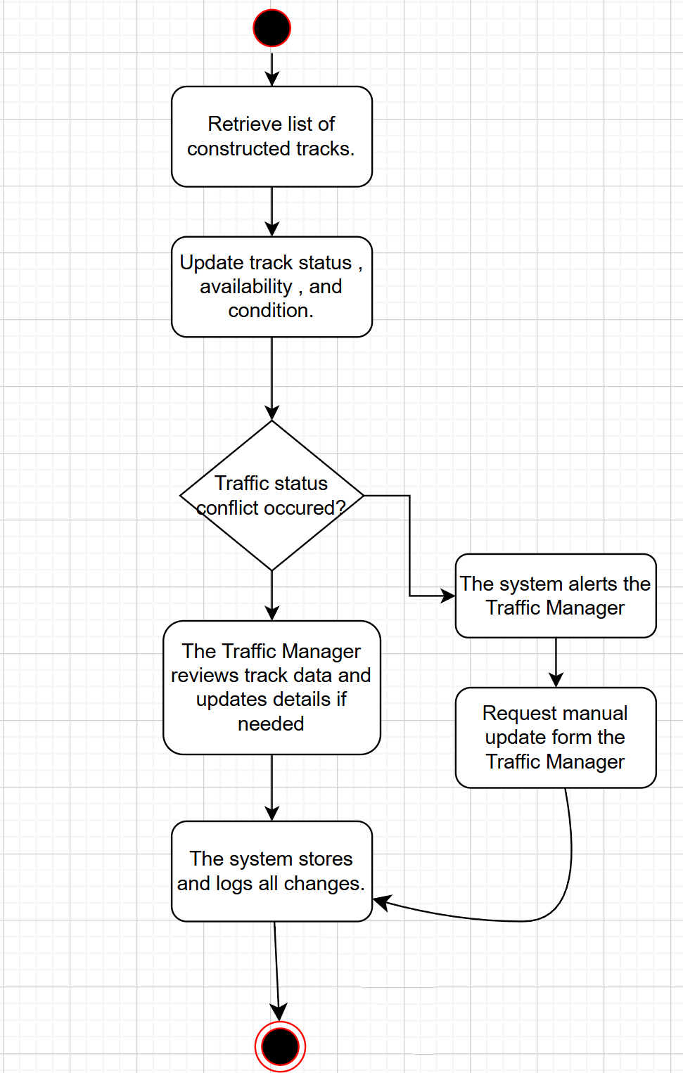

| UC Name | | ***S_INT_02 : External Railway System Interaction*** | | | | | | | |
| --- | --- | --- | --- | --- | --- | --- | --- | --- | --- |
| Summary | | The system must facilitate secure and efficient data exchange with external railway systems to coordinate train operations beyond its jurisdiction. | | | | | | | |
| Actors | | * ***Primary Actor****: System (S)* * ***Secondary Actors****: External Railway System (EXT), Traffic Manager (TM)* | | | | | | | |
| Preconditions | | * The system must have an established connection with external railway databases or APIs. * The external system must allow authorized data exchanges. | | | | | | | |
| Description of the Main Sequence | | * **1.** The system sends or receives operational data from external railway systems. * **2.** The system validates incoming data for accuracy and consistency. * **3.** The system updates relevant internal records (e.g., train schedules, track availability). * **4.** If required, the Traffic Manager reviews and confirms data integration. * **5.** The system logs all transactions and updates. | | | | | | | |
| Description of the Alternative Sequence | | * **1.** If the external system is unavailable, the system will attempt reconnection and notify the Traffic Manager if retries fail. * **2.** If inconsistencies in received data are detected, the system will flag them for manual verification and corrective action. | | | | | | | |
| Non functional requirements | | * **Interoperability** → The system must integrate with external railway networks using standardized communication protocols (e.g., XML, JSON, API). * **Security** → All data exchanges must be encrypted and authenticated to prevent unauthorized access. * **Audit Logging** → Every interaction with external systems must be recorded with timestamps and details for monitoring and compliance. | | | | | | | |
| Postconditions | | * External railway system data is successfully exchanged and integrated. * Any modifications or failures in data exchange are logged for traceability. | | | | | | | |

**UC2*: S_INT_02 : External Railway System Interaction***

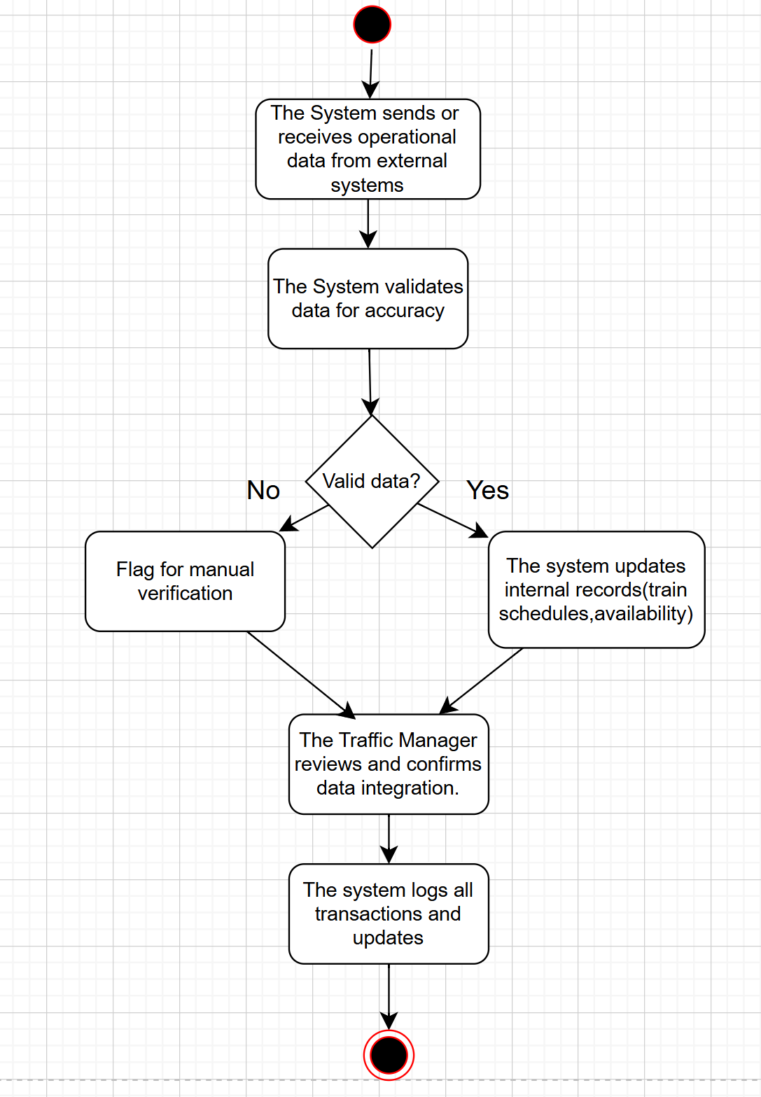

| UC Name | | **S_TRK_03:** ***Track Station Availability and Condition*** | | | | | | | |
| --- | --- | --- | --- | --- | --- | --- | --- | --- | --- |
| Summary | | The system maintains and updates the status and condition of all railway stations, ensuring real-time tracking for management and operational purposes. | | | | | | | |
| Dependency | | **S_SCH_06 (Track Train Schedules and Itineraries)** – If a station is unavailable, it may require schedule adjustments. | | | | | | | |
| Actors | | * **Primary Actor**: System (S) * **Secondary Actor(s)**: Station Manager (SM), Traffic Manager (TM) | | | | | | | |
| Preconditions | | * The system is operational and has access to station data. * Station status data must be available or manually inputted by a Station Manager. | | | | | | | |
| Description of the Main Sequence | | * **1.** The system continuously monitors station data (availability and condition). * **2.** Station managers can manually update station status if needed. * **3.** The system stores updates and alerts relevant users (e.g., traffic managers) of critical station status changes. * **4.** The updated station status is reflected across the system in real time. | | | | | | | |
| Description of the Alternative Sequence | | * If automatic monitoring fails, the system prompts station managers to manually input station status. * If station data is unavailable, the system notifies traffic managers of missing information. | | | | | | | |
| Non functional requirements | | * **High Availability & Reliability** → The system must be operational 24/7 to continuously track station conditions without downtime. * **Real-time Data Processing** → The system must update station availability and condition in real time to ensure accurate and timely information. * **Fault Tolerance** → The system should handle failures gracefully (e.g., if sensor data is missing, allow manual updates). | | | | | | | |
| Postconditions | | * The system has an updated record of all station statuses. | | | | | | | |

***UC3 :* S_TRK_03:** ***Track Station Availability and Condition***

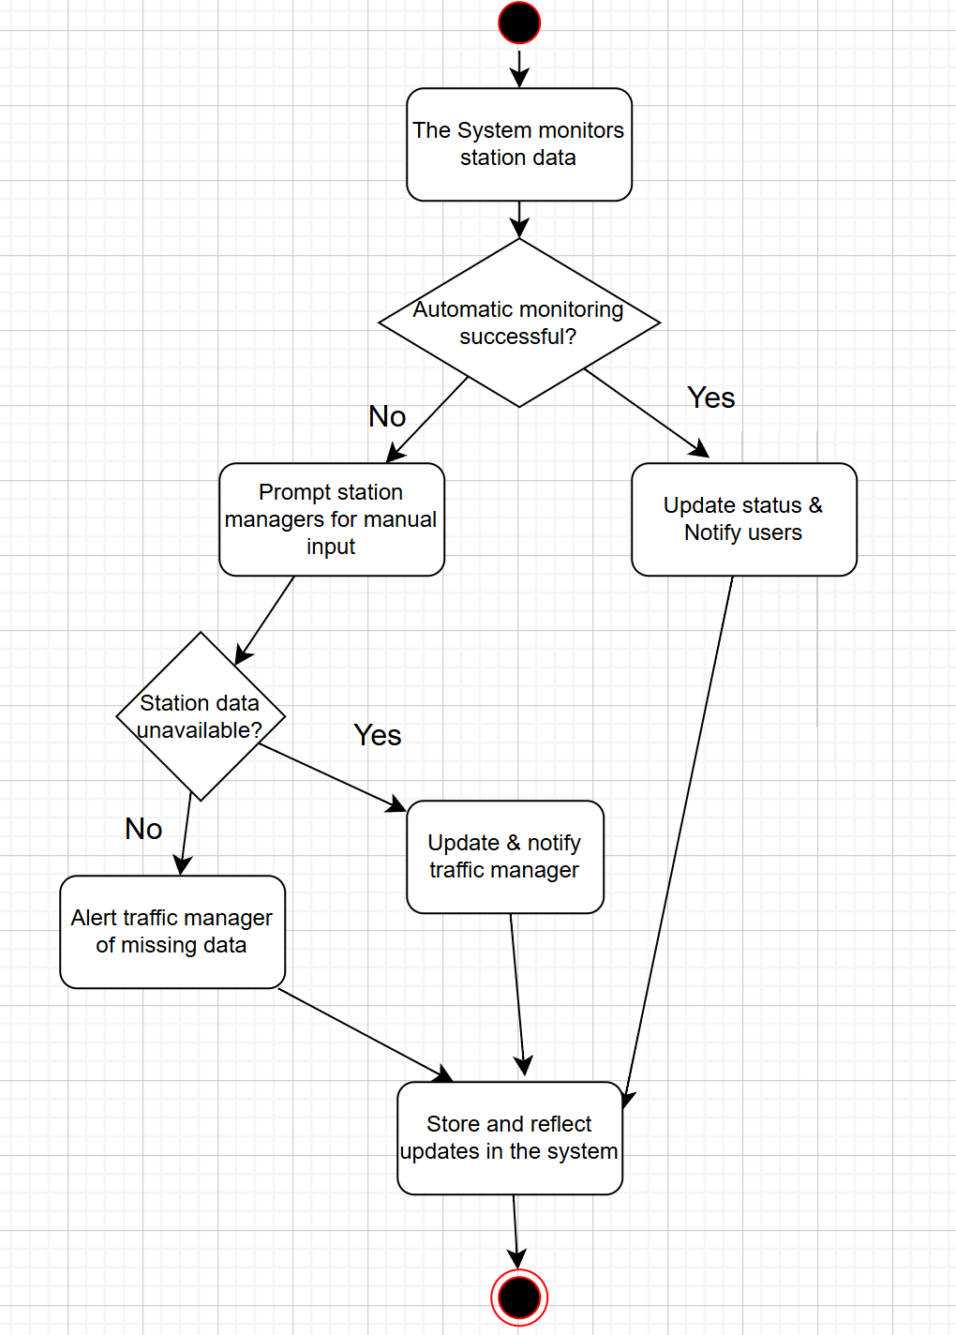

| UC Name | | ***S_TRK_04: Railway Availability and Condition Tracking*** | | | | | | | |
| --- | --- | --- | --- | --- | --- | --- | --- | --- | --- |
| Summary | | The system must continuously monitor and update the availability and condition of railway tracks to ensure safe and efficient train operations. | | | | | | | |
| Dependency | | * **S_TRK_03** (Track Station Availability and Condition) → Stations depend on track conditions. | | | | | | | |
| Actors | | * **Primary Actor:** **System (S)** * **Secondary Actor(s):** **Traffic Manager (TM), Station Manager (SM)** | | | | | | | |
| Preconditions | | * The system must have access to real-time track status data. * **Data Sources**: Track conditions must be provided by automated sensors (if available) or manual input by authorized personnel. * **Access Control** : Only authorized Traffic Managers (TM) or system processes can update track condition data. | | | | | | | |
| Description of the Main Sequence | | * ***1*.** The system collects real-time data on railway track conditions (e.g., damage, obstructions). * **2.** The system updates track availability in the database. * **3.** If a track is unavailable, the system notifies relevant personnel (Traffic Manager, Station Manager). * **4.** The system logs all status updates and notifications. | | | | | | | |
| Description of the Alternative Sequence | | * **1.** If the system detects missing or conflicting data, it requests verification from authorized personnel. * **2.** If track conditions require urgent maintenance, the system escalates an alert to maintenance teams. | | | | | | | |
| Non functional requirements | | * The system must process and store real-time track data with high precision. * The system must provide uninterrupted monitoring to prevent operational delays. * Only authorized users can modify track condition data. * All updates must be recorded with timestamps and user details for audit purposes. | | | | | | | |
| Postconditions | | * Railway track status is updated and accessible to relevant personnel. * Any maintenance needs or disruptions are logged and communicated. | | | | | | | |

***UC 4: S_TRK_04: Railway Availability and Condition Tracking***

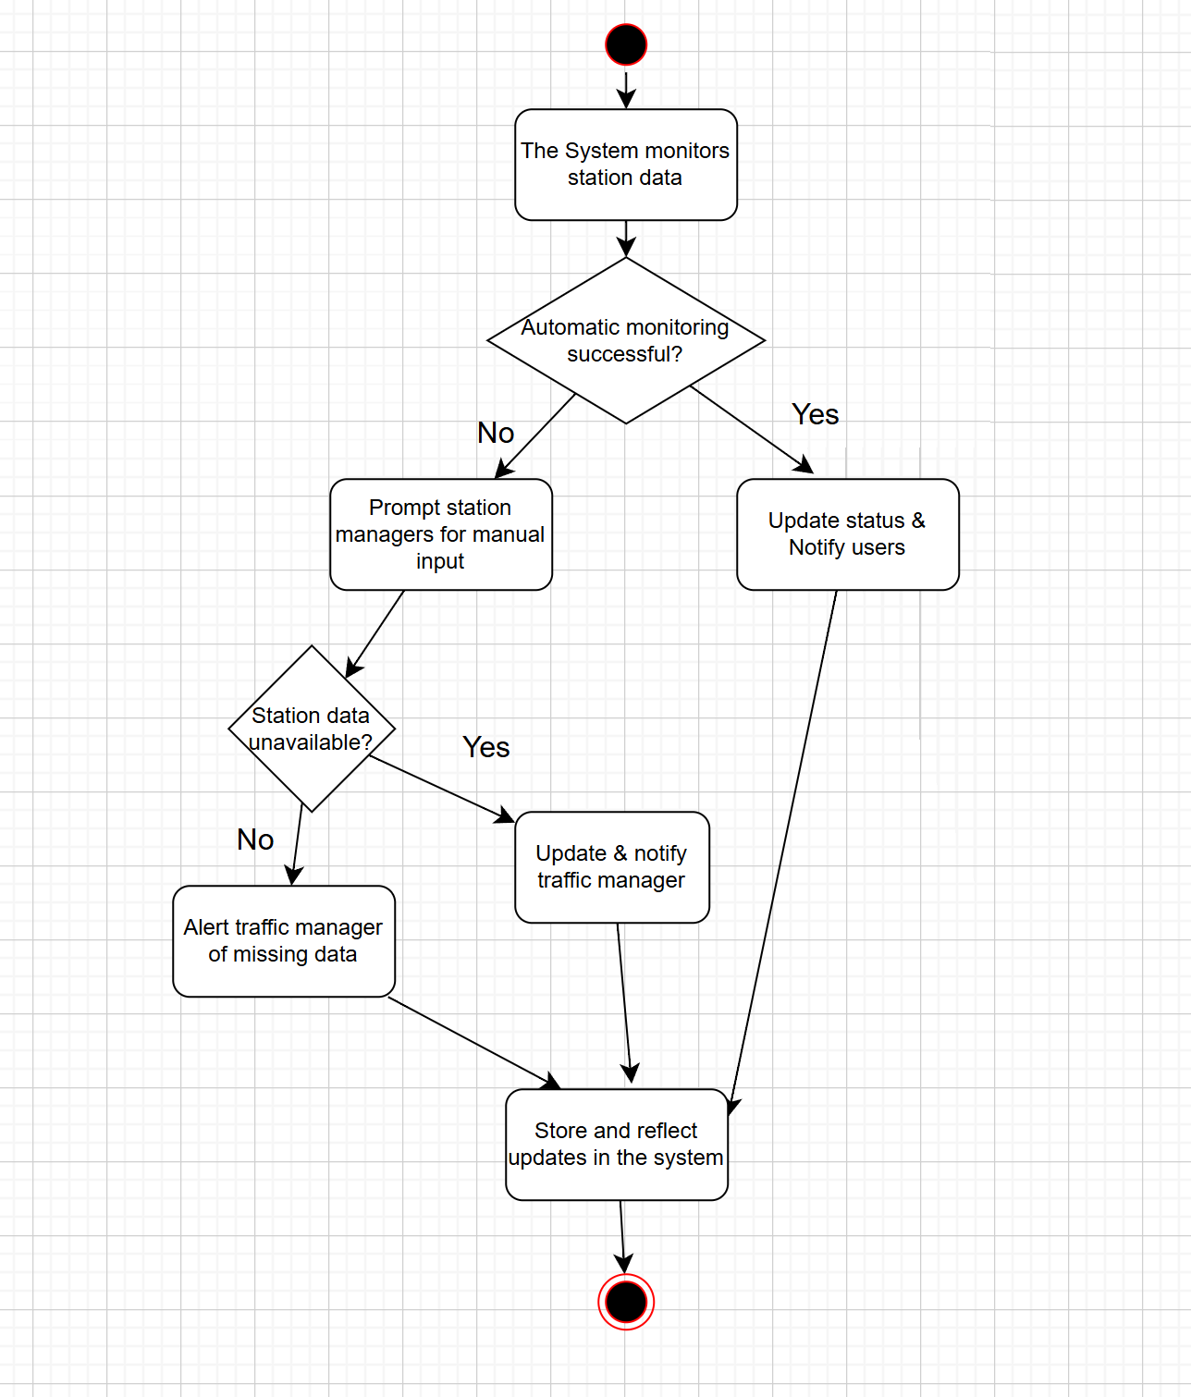

| UC Name | | **S_TRK_05 : Train Car Availability and Condition Tracking** | | | | | | | |
| --- | --- | --- | --- | --- | --- | --- | --- | --- | --- |
| Summary | | The system must monitor, update, and store accurate data on train car availability and condition to support scheduling and maintenance. | | | | | | | |
| Dependency | | * **S_SCH_06** (Track Train Schedules and Itineraries) → Scheduling depends on train car availability. * **S_TRK_04** (*Track Railway Availability and Condition*) → Train cars operate on available tracks. * **S_PER_07** (*Track Human Personnel Availability and Condition*) → Maintenance teams may be needed for repairs. | | | | | | | |
| Actors | | * **Primary Actor**: System (S) * **Secondary Actor(s)**: Traffic Manager (TM), Maintenance Personnel (E) | | | | | | | |
| Preconditions | | * The system must receive data from sensors, manual inputs, or maintenance logs. * Train car statuses (available, in maintenance, or out of service) must be regularly updated. * Only authorized personnel can modify train car condition records | | | | | | | |
| Description of the Main Sequence | | * **1.** The system collects and updates train car condition data. * **2.** The system checks availability for scheduling. * **3.** If a train car is unavailable, the system flags it for maintenance. * **4.** The system logs all updates and notifies relevant personnel if necessary. | | | | | | | |
| Description of the Alternative Sequence | | * **1.** If missing or conflicting data is detected, the system requests verification from an authorized user. * **2**. If a train car is out of service, the system automatically excludes it from scheduling. | | | | | | | |
| Non functional requirements | | * **Accuracy** : Data must be up-to-date and reliable. * **Security** : Only authorized users can modify records. * **Logging** : All updates must be logged with timestamps for auditing. * **Performance** :The system should process and update train car statuses in real time. | | | | | | | |
| Postconditions | | * Train car data is updated and stored. * Scheduling and maintenance teams have accurate availability records. * Any unavailable train cars are flagged for attention. | | | | | | | |

***UC 5:* S_TRK_05 : Train Car Availability and Condition Tracking**

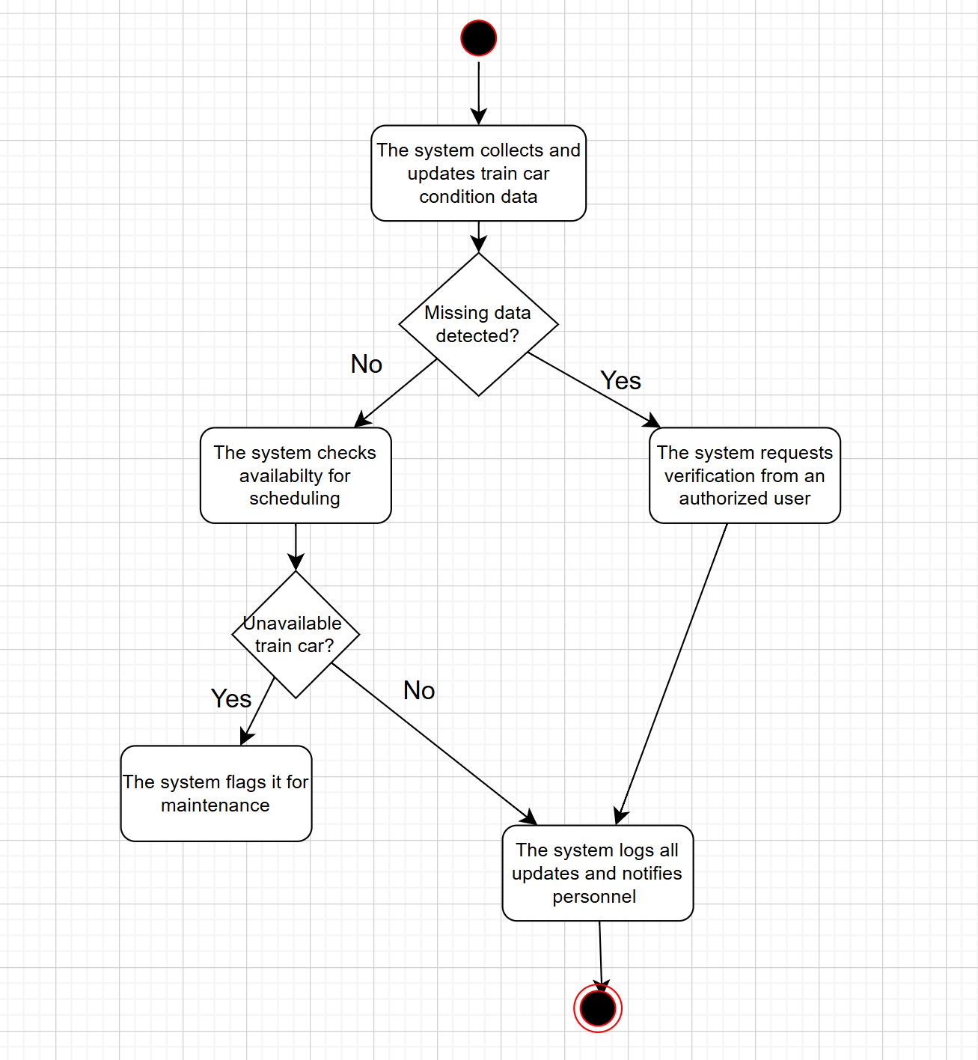

| UC Name | | ***S_SCH_06:Maintain Train Schedule and Itineraries*** | | | | | | | |
| --- | --- | --- | --- | --- | --- | --- | --- | --- | --- |
| Summary | | *T*he system must maintain and update the schedule of trains and their specific itineraries to ensure efficient operations and route planning. | | | | | | | |
| Dependency | | * ***S_TRK_03 (Station Tracking)*** *and* ***S_TRK_04 (Railway Tracking)*** *for track and station availability..* | | | | | | | |
| Actors | | ***Primary Actor:*** *System (S)*  ***Secondary Actor (s):*** *Traffic Manager (TM), Station Manager (SM)* | | | | | | | |
| Preconditions | | * The system must store and maintain an up-to-date database of train schedules and itineraries. * Traffic and Station Managers must have the appropriate permissions to access and modify schedules. | | | | | | | |
| Description of the Main Sequence | | * **1**. The system retrieves the current train schedule. * **2.** The Traffic Manager or Station Manager modifies or updates a schedule. * **3.** The system verifies track and station availability. * **4**. The system saves and updates the new schedule. * **5.** The system notifies relevant users of schedule changes. | | | | | | | |
| Description of the Alternative Sequence | | * **1.** If a schedule conflicts with existing reservations: **a)**The system alerts the Traffic Manager.  b)The Traffic Manager adjusts the schedule accordingly. * **2.** If a train is unavailable:   **a)**The system prevents scheduling.  b)The system suggests alternative time slots or trains. | | | | | | | |
| Non functional requirements | | * **Performance:** The system must update schedule changes within **5 seconds** to ensure real-time accuracy. * **Availability:** The scheduling feature must be operational 24/7 with minimal downtime. * **Security:** Only authorized personnel (Traffic Managers and System Admins) can modify train schedules. | | | | | | | |
| Postconditions | | * *T*he updated schedule is saved and accessible to relevant users. * Notifications are sent to affected personnel and passengers about any schedule changes. * Any scheduling conflicts or errors are logged and flagged for review. | | | | | | | |

**UC 6: *S_SCH_06:Maintain Train Schedule and Itineraries***

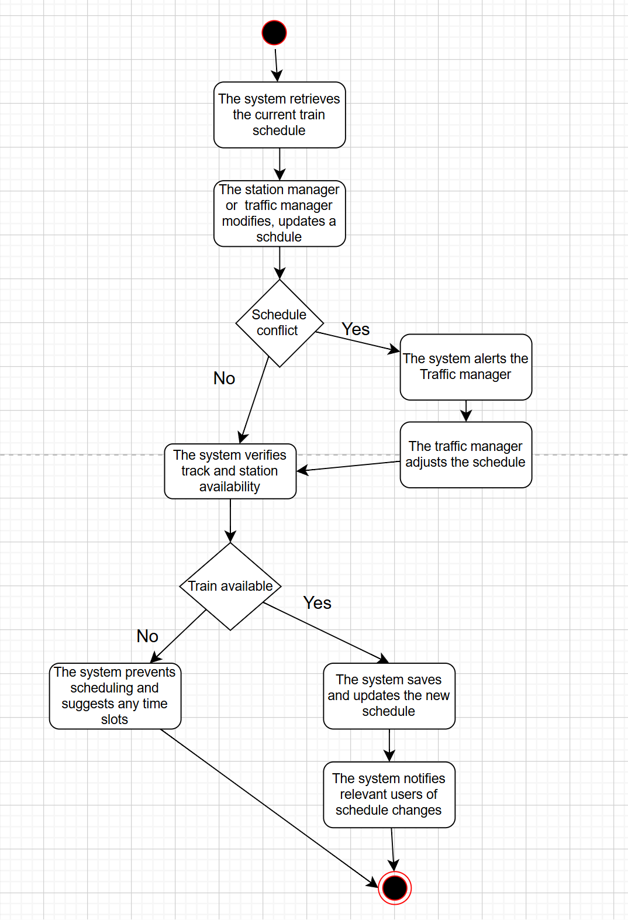

| UC Name | | ***S_PER_07 – Monitor Human Personnel Availability and Condition*** | | | | | | | |
| --- | --- | --- | --- | --- | --- | --- | --- | --- | --- |
| Summary | | The system tracks and updates personnel availability and condition to optimize workforce management, scheduling, and operational efficiency. | | | | | | | |
| Dependency | | * **SM_PER_13 – Access Personnel Information:** Station Managers may need this data. * **S_LOG_38 – System Logging:** Logs personnel updates. | | | | | | | |
| Actors | | * **Primary Actor:** **Station Manager (SM)** – Monitors personnel status. * **Secondary Actors:**   **1.Employee (E):** Updates their own availability and condition.  2.**System (S):** Stores, updates, and displays personnel data. | | | | | | | |
| Preconditions | | * The system contains updated personnel records. * Employees have logged their availability and condition. * The Station Manager has the required access rights. | | | | | | | |
| Description of the Main Sequence | | * **1.** Station Manager logs into the system. * **2.** Station Manager navigates to the personnel monitoring module. * **3.** System retrieves and displays real-time personnel availability and condition. * **4.** Station Manager analyzes workforce availability for task assignments. * **5.** If shortages are detected, the Station Manager takes action (e.g., shift reassignments). * **6.** System logs all actions and updates personnel records. | | | | | | | |
| Description of the Alternative Sequence | | 1. If an employee has not updated their availability:  * The system assumes the previous availability status. * If the status remains unchanged for too long, the system alerts the Station Manager.   2.If critical staff shortages are detected:   * The system flags the issue and suggests alternatives (e.g., reassigning tasks). | | | | | | | |
| Non functional requirements | | * **Performance:** Data retrieval must be instant (less than 3 seconds response time). * **Security:** Only authorized managers can view/edit personnel records. * **Usability:** Personnel availability must be clearly displayed in an intuitive dashboard. | | | | | | | |
| Postconditions | | * The Station Manager has accurate personnel data for workforce planning. * Any staff shortages or concerns are flagged for further action. * All actions taken are logged for audit purposes. | | | | | | | |

***UC 7: S_PER_07 – Monitor Human Personnel Availability and Condition***

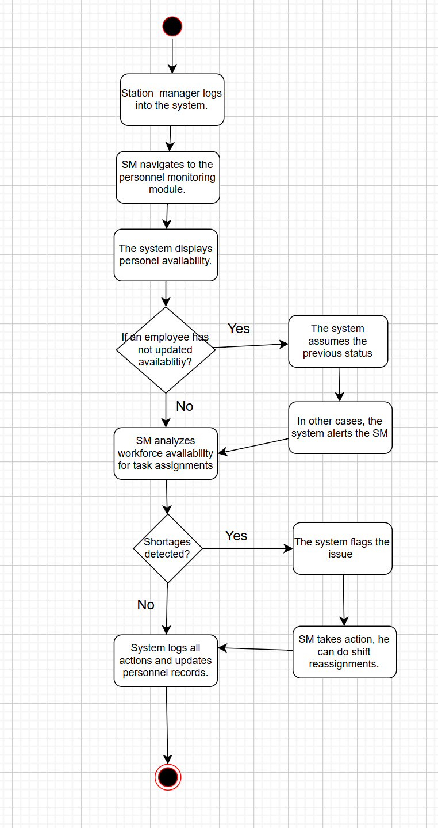

| UC Name | | ***TM MNG_08 – Manage Passenger Information*** | | | | | | | |
| --- | --- | --- | --- | --- | --- | --- | --- | --- | --- |
| Summary | | The system must securely store and manage passenger information for ticketing, travel records, and customer service. | | | | | | | |
| Dependency | | * **None explicitly stated, but likely depends on UC for user authentication and authorization** | | | | | | | |
| Actors | | **Primary Actor: System (S)**  **Secondary Actors: Ticketing Agent (TA), Customer Service Representative (CSR), Passenger (P)**  **Other Actors: Auditor (A), Law Enforcement (LE)** | | | | | | | |
| Preconditions | | * The system must have a secure database for storing passenger information. * Relevant actors (TA, CSR) must be authenticated and authorized. | | | | | | | |
| Description of the Main Sequence | | * **The Ticketing Agent or Passenger (via online portal) enters passenger details (e.g., name, contact information).** * **The system validates the entered information.** * **The system securely stores the passenger information.** * **When a ticket is purchased, the system links the passenger information to the ticket record.** * **During travel, the system may retrieve passenger information for verification.** * **Customer Service Representatives can access and update passenger information (with appropriate authorization) for support purposes.** | | | | | | | |
| Description of the Alternative Sequence | | * If data validation fails, the system prompts the actor to correct the information. * If a passenger requests to update their information, the system verifies their identity before allowing changes. | | | | | | | |
| Non functional requirements | | **Security: Passenger data must be encrypted and protected from unauthorized access.**  **Data Integrity: The system must ensure the accuracy and consistency of passenger information.**  **Privacy: The system must comply with relevant data privacy regulations.** | | | | | | | |
| Postconditions | | * Passenger information is securely stored and linked to relevant records. * Authorized users can access and manage passenger information as needed. * Any staff shortages or concerns are flagged for further action. * All actions taken are logged for audit purposes. | | | | | | | |

| UC Name | | ***TM MNG_09 – Manage Train Schedules*** | | | | | | | |
| --- | --- | --- | --- | --- | --- | --- | --- | --- | --- |
| Summary | | The Traffic Manager must be able to create, update, and delete schedules for trains under their jurisdiction. | | | | | | | |
| Dependency | | * **TM MNG 01 (Track Constructed Tracks Under Management) → Track availability must be considered when scheduling.** | | | | | | | |
| Actors | | **Primary Actor: Traffic Manager (TM)**  **Secondary Actor: System (S)**  **Other Actors: Train Operator (TO), Maintenance Staff (MS)** | | | | | | | |
| Preconditions | | * The system must have access to track availability and train information. * The Traffic Manager must be authenticated and authorized. | | | | | | | |
| Description of the Main Sequence | | * **The Traffic Manager initiates the schedule management function.** * **The Traffic Manager selects the action (create, update, delete).** * **The Traffic Manager enters or modifies schedule details (e.g., train ID, origin, destination, departure/arrival times, track assignment).** * **The system validates the schedule against track availability and other constraints.** * **The system saves the new or updated schedule.** * **If deleting, the system confirms the deletion with the Traffic Manager and removes the schedule.** | | | | | | | |
| Description of the Alternative Sequence | | * If the schedule conflicts with track availability or other existing schedules, the system alerts the Traffic Manager and provides conflict details. * If the Traffic Manager attempts to delete a schedule with active bookings, the system may issue a warning or prevent deletion based on system policy. | | | | | | | |
| Non functional requirements | | **Validation: The system must perform thorough validation of schedule data to prevent errors.**  **Concurrency Control: The system must manage concurrent schedule modifications by multiple Traffic Managers.**  **Audit Logging: All schedule changes must be logged with timestamps and user information.** | | | | | | | |
| Postconditions | | * Train schedules are created, updated, or deleted as requested by the Traffic Manager, adhering to system constraints. * All schedule changes are logged for auditing purposes. | | | | | | | |

| UC Name | | ***TM VW_10 – View Railway Information*** | | | | | | | |
| --- | --- | --- | --- | --- | --- | --- | --- | --- | --- |
| Summary | | The Traffic Manager must be able to view train information, station information, and track information. | | | | | | | |
| Dependency | | * **TM MNG 01 (Track Constructed Tracks Under Management) → Access to track information.** * **Potentially other UCs related to managing train and station data.** | | | | | | | |
| Actors | | **Primary Actor: Traffic Manager (TM)**  **Secondary Actor: System (S)**  **Other Actors: Network Control (NC), Emergency Services (ES)** | | | | | | | |
| Preconditions | | * The system must have stored data for trains, stations, and tracks. * The Traffic Manager must be authenticated and authorized. | | | | | | | |
| Description of the Main Sequence | | * **The Traffic Manager selects the type of information to view (train, station, or track).** * **The system presents a list or a search interface for the selected information type.** * **The Traffic Manager selects a specific item (e.g., a train ID, a station name, a track ID).** * **The system displays the detailed information for the selected item.** | | | | | | | |
| Description of the Alternative Sequence | | * If the Traffic Manager enters invalid search criteria, the system displays an error message. * If no information matches the search criteria, the system informs the Traffic Manager. | | | | | | | |
| Non functional requirements | | **Performance: Information should be retrieved and displayed efficiently.**  **Security: Access to sensitive information should be controlled based on user roles and permissions.** | | | | | | | |
| Postconditions | | * The Traffic Manager can successfully view the requested train, station, or track information. | | | | | | | |

| UC Name | | ***SM MNG_11 – Allocate station personel*** | | | | | | | |
| --- | --- | --- | --- | --- | --- | --- | --- | --- | --- |
| Summary | | The Station Manager must be able to allocate human personnel to complete tasks on stations under their jurisdiction. | | | | | | | |
| Dependency | | * **SM MNG 02 (Access Personnel Information) → The Station Manager needs to know available personnel.** | | | | | | | |
| Actors | | **Primary Actor: Station Manager (SM)**  **Secondary Actor: System (S)**  **Other Actors: Personnel (P), Security Staff (SS)** | | | | | | | |
| Preconditions | | * The system must have a list of station personnel and their roles/availability. * The Station Manager must be authenticated and authorized for their station(s). | | | | | | | |
| Description of the Main Sequence | | * **The Station Manager accesses the personnel allocation module.** * **The Station Manager selects a task or area requiring personnel.** * **The system displays a list of available personnel suitable for the task.** * **The Station Manager assigns one or more personnel to the task, specifying the time and duration if necessary.** * **The system records the personnel allocation.** | | | | | | | |
| Description of the Alternative Sequence | | * If no suitable personnel are available, the system informs the Station Manager. * If the Station Manager attempts to allocate personnel who are already assigned or unavailable, the system issues a warning. | | | | | | | |
| Non functional requirements | | **Usability: The personnel allocation interface should be intuitive and easy to use.**  **Real-time Updates: Personnel availability should be updated in a timely manner.** | | | | | | | |
| Postconditions | | * Personnel are allocated to tasks as specified by the Station Manager. * The system maintains a record of personnel allocations. | | | | | | | |

| UC Name | | ***TM PRVT_12 – Prevent Scheduling/Operational Errors*** | | | | | | | |
| --- | --- | --- | --- | --- | --- | --- | --- | --- | --- |
| Summary | | The system must prevent Traffic Managers from making critical scheduling or operational errors using validation checks. | | | | | | | |
| Dependency | | * **TM MNG 03 (Manage Train Schedules) → Validation is applied during schedule creation/modification.** * **Potentially other UCs involving operational decisions.** | | | | | | | |
| Actors | | **Primary Actor: System (S)**  **Secondary Actor: Traffic Manager (TM)**  **Other Actors: System Administrator (SA), Safety Inspector (SI)** | | | | | | | |
| Preconditions | | * The system must have defined rules and constraints for scheduling and operations. * The Traffic Manager is attempting to perform an action that could lead to an error (e.g., creating an overlapping schedule, assigning a train to an unavailable track). | | | | | | | |
| Description of the Main Sequence | | * **The Traffic Manager attempts to create or modify a schedule or initiate an operational action.** * **The system automatically performs validation checks against predefined rules (e.g., track availability, time conflicts, safety regulations).** * **If a potential error is detected, the system displays an alert or error message to the Traffic Manager, explaining the issue.** * **The system prevents the action from being completed until the error is corrected.** | | | | | | | |
| Description of the Alternative Sequence | | * In some cases, the system might offer suggestions or alternative solutions to resolve the potential error. * For certain less critical errors, the system might issue a warning but allow the Traffic Manager to proceed with caution (with appropriate logging). | | | | | | | |
| Non functional requirements | | **Reliability: The validation checks must be accurate and effective in preventing errors.**  **Usability: Error messages should be clear, informative, and guide the Traffic Manager on how to resolve the issue.** | | | | | | | |
| Postconditions | | * Critical scheduling or operational errors are prevented by the system's validation checks. | | | | | | | |

| UC Name | | ***SM VW_13 – Access Personnel Information*** | | | | | | | |
| --- | --- | --- | --- | --- | --- | --- | --- | --- | --- |
| Summary | | The Station Manager needs to be able to access personnel information for staff under their jurisdiction. | | | | | | | |
| Dependency | | * **None explicitly stated, but relies on the system storing personnel data.** | | | | | | | |
| Actors | | **Primary Actor: Station Manager (SM)**  **Secondary Actor: System (S)**  **Other Actors: Human Resources (HR)** | | | | | | | |
| Preconditions | | * The system must have stored personnel information. * The Station Manager must be authenticated and authorized for their station(s). | | | | | | | |
| Description of the Main Sequence | | * **The Station Manager accesses the personnel information module.** * **The system displays a list of personnel assigned to their station(s).** * **The Station Manager can select a specific employee to view their details (e.g., contact information, roles, availability).** | | | | | | | |
| Description of the Alternative Sequence | | * The system may provide search or filtering options to help the Station Manager find specific personnel. * Access to certain sensitive personnel information might be restricted based on the Station Manager's role and permissions. | | | | | | | |
| Non functional requirements | | **Security: Access to personnel information must be controlled to authorized personnel only.**  **Usability: The interface for viewing personnel information should be easy to navigate.** | | | | | | | |
| Postconditions | | * The Station Manager can view the necessary personnel information for their staff. | | | | | | | |

| UC Name | | ***SM VW_14 – View Train Schedules (Station Jurisdiction)*** | | | | | | | |
| --- | --- | --- | --- | --- | --- | --- | --- | --- | --- |
| Summary | | The Station Manager needs to be able to view train schedules relevant to the station(s) under their jurisdiction. | | | | | | | |
| Dependency | | * **TM MNG 03 (Manage Train Schedules) → Schedules must exist in the system.** | | | | | | | |
| Actors | | **Primary Actor: Station Manager (SM)**  **Secondary Actor: System (S)**  **Other Actors: Customer (C), Information Desk Clerk (IDC)** | | | | | | | |
| Preconditions | | * Train schedules must be stored in the system. * The system must know which trains are scheduled to stop at or pass through the Station Manager's jurisdiction. * The Station Manager must be authenticated and authorized for their station(s). | | | | | | | |
| Description of the Main Sequence | | * **The Station Manager accesses the train schedule viewing module.** * **The system automatically displays the train schedules relevant to the Station Manager's station(s) for the current day or a specified period.** * **The Station Manager can view details such as arrival and departure times, track assignments, and train IDs.** | | | | | | | |
| Description of the Alternative Sequence | | * The system may allow the Station Manager to filter the schedule (e.g., by direction, specific train). * If there are disruptions or changes to the schedule, the system should ideally highlight these to the Station Manager. | | | | | | | |
| Non functional requirements | | **Accuracy: The displayed schedule information must be up-to-date and accurate.**  **Performance: The schedule information should be retrieved and displayed quickly.** | | | | | | | |
| Postconditions | | * The Station Manager can view the train schedules relevant to their station(s). | | | | | | | |

| UC Name | | ***TM_VIW_15 - Manage Train Schedules*** | | | | | | | |
| --- | --- | --- | --- | --- | --- | --- | --- | --- | --- |
| Summary | | This use case describes how the Traffic Manager views the real-time location of every train within their jurisdiction to monitor operations and ensure efficient scheduling. | | | | | | | |
| Dependency | | * ***S_TRK_05*** *(system maintaining accurate data on train car availability and condition).* | | | | | | | |
| Actors | | * **Primary Actor**: Traffic Manager (TM) * **Secondary Actor**: System (S) | | | | | | | |
| Preconditions | | * The Traffic Manager is logged into the system with valid credentials. * Real-time tracking data for trains is available and up-to-date. * The system has synchronized location data from trains. | | | | | | | |
| Description of the Main Sequence | | * **1**. The Traffic Manager navigates to the "Train Monitoring" dashboard in the system. * **2.** The system retrieves real-time location data for all trains under the Traffic Manager’s jurisdiction. * **3.** The system displays a map or list view showing each train’s current location, status, and route. * **4.** The Traffic Manager reviews the displayed information to monitor train movements. | | | | | | | |
| Description of the Alternative Sequence | | * **1 .**  If real-time data is temporarily unavailable (e.g., due to a network issue), the system displays the last known location of each train with a timestamp(record time or date of). * **2:** The system notifies the Traffic Manager of the data delay and estimated resolution time. * **3:** The Traffic Manager decides whether to wait for updated data or proceed with the last known information. | | | | | | | |
| Non functional requirements | | * ***Performance:*** *The system must display real-time train locations within 1 second of the request.* * ***Security:*** *Access to train location data is restricted to authorized Traffic Managers via role-based access control and encrypted communication (SSL/TLS).* * ***Reliability:*** *The system must ensure high uptime for real-time tracking features.* | | | | | | | |
| Postconditions | | * The Traffic Manager has successfully viewed the real-time locations of all trains under their jurisdiction(authority). | | | | | | | |

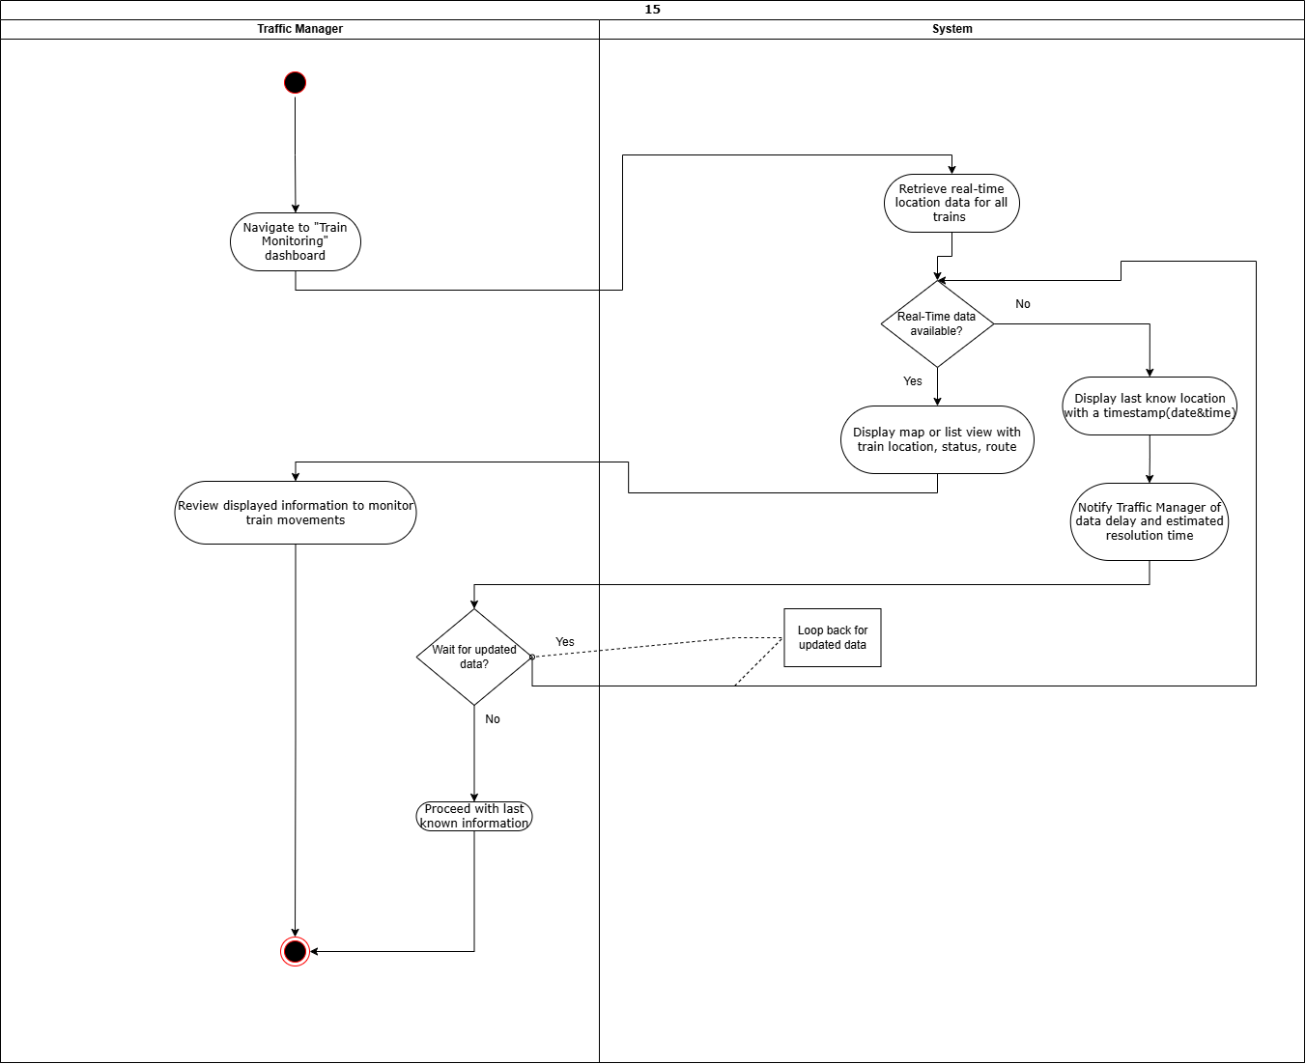

| UC Name | | ***SM_PER_16 – Access Passenger Details*** | | | | | | | |
| --- | --- | --- | --- | --- | --- | --- | --- | --- | --- |
| Summary | | The Station Manager accesses passenger details in a **controlled and secure** manner to assist with station-related operations while ensuring data privacy and compliance with regulations. | | | | | | | |
| Dependency | | * ***S_PER_08 – Track Passenger Information*** *(Passenger details must be stored in the system).* * ***U_AUTH_34 – Login/Logout Functionality*** *(Only authorized personnel can access data).* | | | | | | | |
| Actors | | * ***Primary Actor:******Station Manager (SM)*** *– Requests access to passenger details.* * ***Secondary Actor:******System (S)*** *– Verifies authorization and retrieves passenger details.* | | | | | | | |
| Preconditions | | * *The requested passenger details are* ***relevant to station operations*** *(e.g., ticket verification, lost items, assistance requests).* | | | | | | | |
| Description of the Main Sequence | | * **1**. Station Manager logs into the system. * **2.** Station Manager navigates to the passenger information section. * **3.** System verifies access permissions based on the manager’s jurisdiction. * **4.** Station Manager enters search criteria (e.g., name, ticket number). * **5.** System retrieves and displays the relevant passenger details. * **6.** Station Manager views necessary information **without modifying** sensitive data. * **7.** System logs the access request for security auditing. | | | | | | | |
| Description of the Alternative Sequence | | * **If the Station Manager lacks proper authorization** the system denies access and displays an error message. * **If the requested passenger record does not exist:** System informs the Station Manager and suggests verifying input details. * **If the system is down:** Access is temporarily unavailable, and an alert is sent to administrators | | | | | | | |
| Non functional requirements | | * **Security:** Access must comply with **data privacy laws** . * **Logging:** All access requests must be **tracked and auditable**. * **Performance:** Passenger details should be retrieved within **3 seconds**. * **Usability:** Interface should be **intuitive and role-restricted**. | | | | | | | |
| Postconditions | | * The system records and logs the access attempt. * Unauthorized attempts trigger **security alerts**. | | | | | | | |

***UC 16: SM_PER_16 – Access Passenger Details***

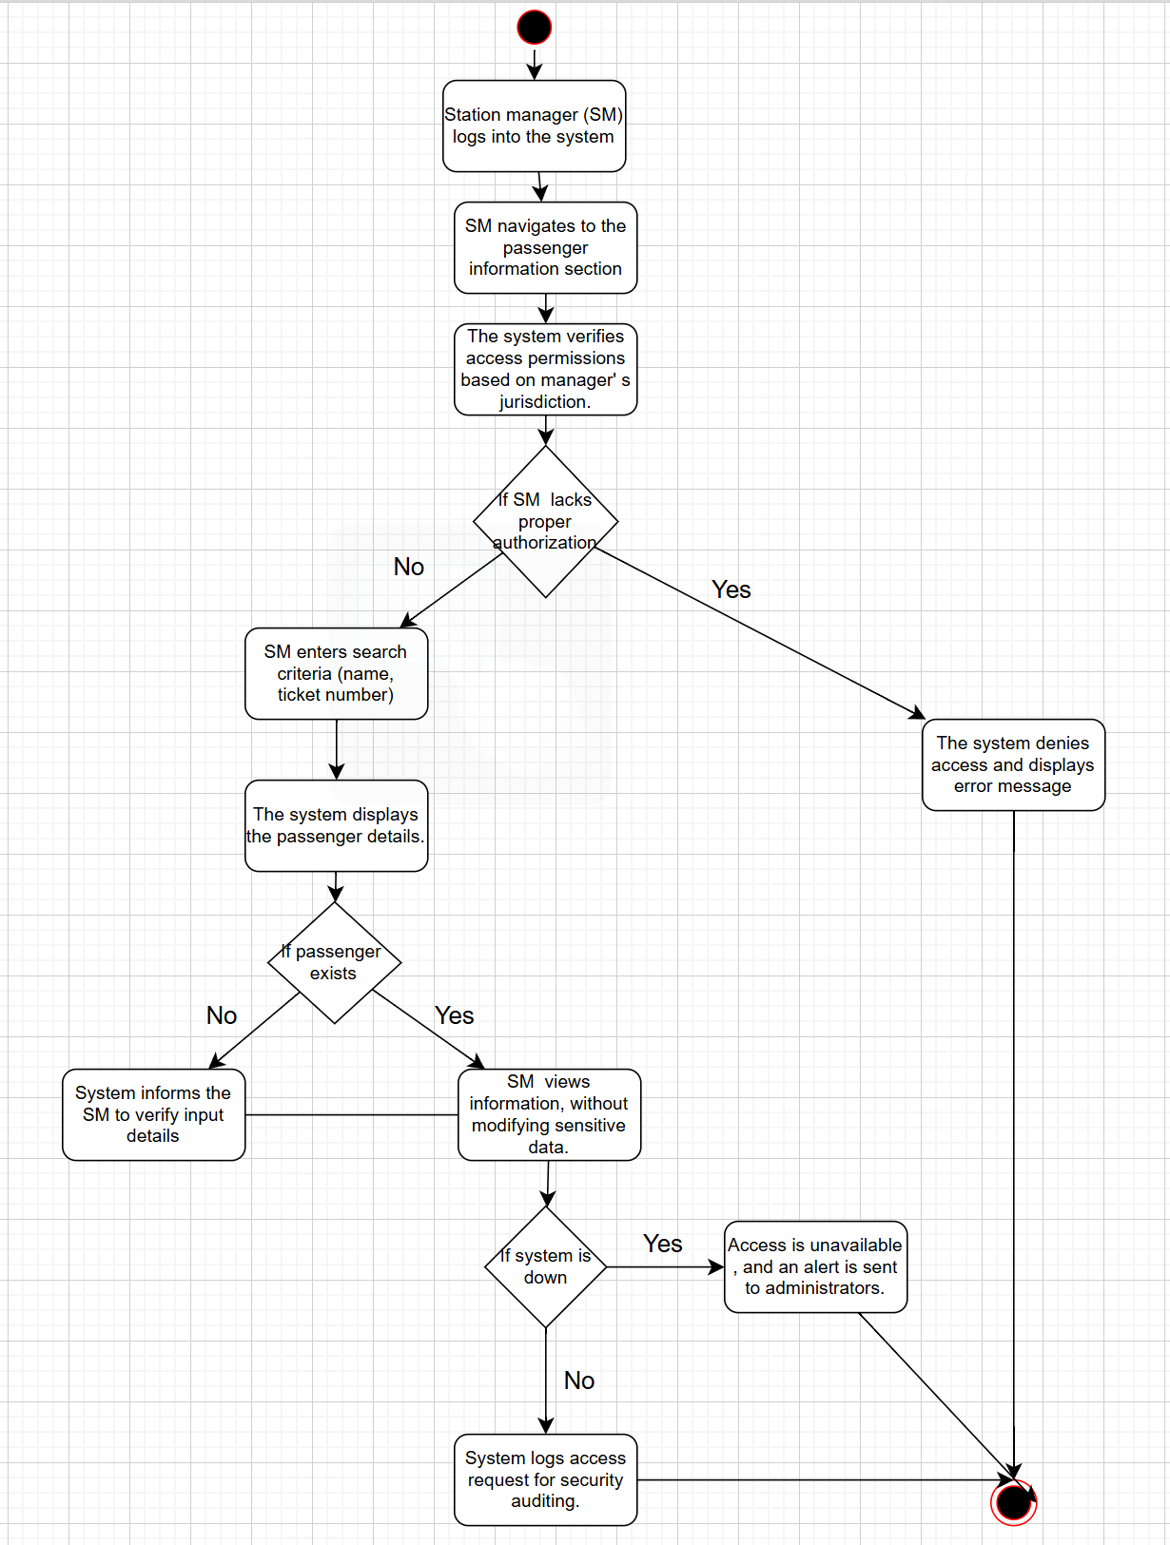

| UC Name | | ***P_TKT_17 – Book Train Ticket*** | | | | | | | |
| --- | --- | --- | --- | --- | --- | --- | --- | --- | --- |
| Summary | | A passenger books a train ticket by selecting an available train, specifying travel preferences (class, seating, or sleeping accommodations), and completing the booking process. | | | | | | | |
| Dependency | | * **S_SCH_06 – Maintain Train Schedules** (Train schedules must be available). * **S_CAP_32 – Capacity Management** (Prevents overbooking). * **S_PAY_20 – Process Payment** (Handles payment for the booking). | | | | | | | |
| Actors | | * **Primary Actor:** **Passenger (P)** – Initiates the ticket booking. * **Secondary Actor:**   System (S) – Processes the booking and verifies availability. | | | | | | | |
| Preconditions | | * The passenger has access to the system (website, mobile app, or ticket booth). * Train schedules and availability data are up to date. * Passenger account is logged in. | | | | | | | |
| Description of the Main Sequence | | * 1. Passenger selects a departure and destination station * 2. System displays available trains with schedules, seat classes, and accommodations. * 3. Passenger selects a preferred train, class, and additional services. * 4. System verifies seat availability. * 5. Passenger enters personal details , selects a payment method and completes the transaction. * 6. Payment is processed successfully. * 7. System generates and issues a ticket with a **unique** booking reference. * 8. Passenger receives a confirmation (email, SMS, or printed ticket). | | | | | | | |
| Description of the Alternative Sequence | | * 1. **If the selected train is fully booked:** System suggests alternative trains or waitlist options. * 2**.If payment fails:** System prompts the passenger to retry or choose another payment method. * **3.If the system is down:** Ticket booking is temporarily unavailable, and an error message is displayed. | | | | | | | |
| Non functional requirements | | * **Performance:** Ticket booking process should be **completed within 10 seconds**. * **Security:** Payment transactions must be secure and comply with industry standards. * **Availability:** The system should be **accessible 24/7**. * **User Experience:** The booking interface should be **intuitive and mobile-friendly**. | | | | | | | |
| Postconditions | | * The ticket is successfully booked and stored in the system. * The passenger receives **a confirmation with booking details**. * Seat availability is **updated** to reflect the new booking. | | | | | | | |

***UC 17: P_TKT_17 – Book Train Ticket***

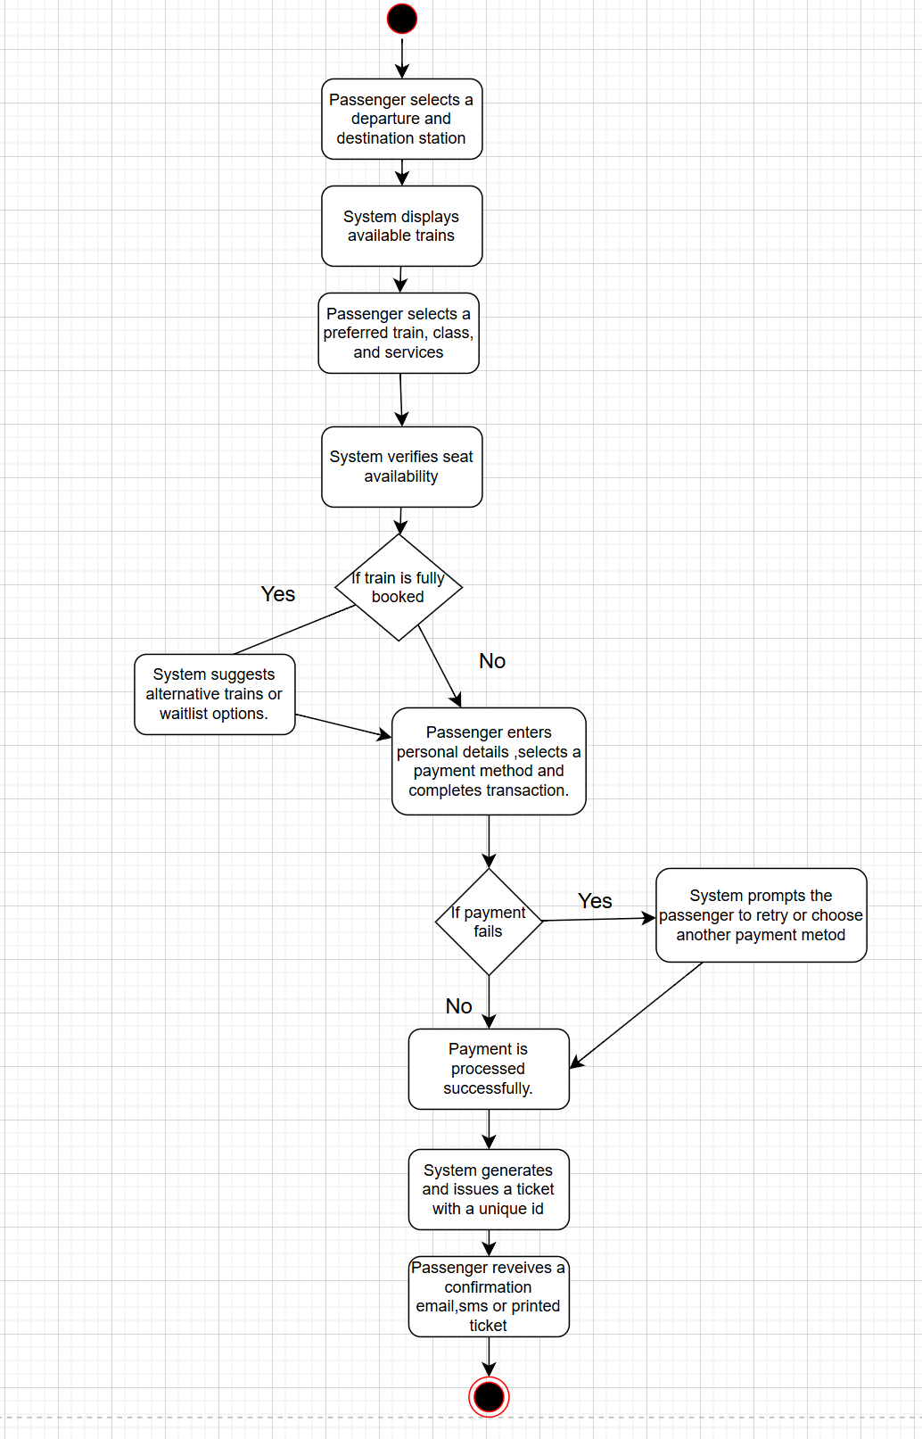

| UC Name | | ***P_VIW_18 - Passenger Views Train Information*** | | | | | | | |
| --- | --- | --- | --- | --- | --- | --- | --- | --- | --- |
| Summary | | This use case outlines how a Passenger accesses train information, such as schedules, routes, and availability, to plan their travel. | | | | | | | |
| Dependency | | * ***S_SCH_06*** *(system maintaining an updated schedule of trains and itineraries).* | | | | | | | |
| Actors | | * ***Primary Actor:*** *Passenger (P)* * ***Secondary Actor:*** *System (S)* | | | | | | | |
| Preconditions | | * *The Passenger has access to the RMS interface (e.g., website or mobile app).* * *Train schedule and status data are available in the system.* | | | | | | | |
| Description of the Main Sequence | | * **1.** The Passenger navigates to the "Train Information" section of the RMS interface. * **2**. The Passenger enters search criteria (e.g., departure station, destination, date). * **3:** The system retrieves and displays available train options, including schedules, routes, and seat availability. * **4:** The Passenger reviews the information to make travel decisions. | | | | | | | |
| Description of the Alternative Sequence | | * **1.** If no trains match the search criteria, the system displays a "No trains available" message. * **2:** The system suggests alternative dates, routes, or nearby stations. * **3:** The Passenger adjusts their search criteria or exits the process. | | | | | | | |
| Non functional requirements | | * **Performance:** Train information must load within 3 seconds of the search request. * **Usability:** The interface must be intuitive and responsive on both desktop and mobile devices. * **Security:** Passenger interactions with the system must be encrypted. | | | | | | | |
| Postconditions | | * The Passenger has successfully viewed available train information for their travel planning. | | | | | | | |

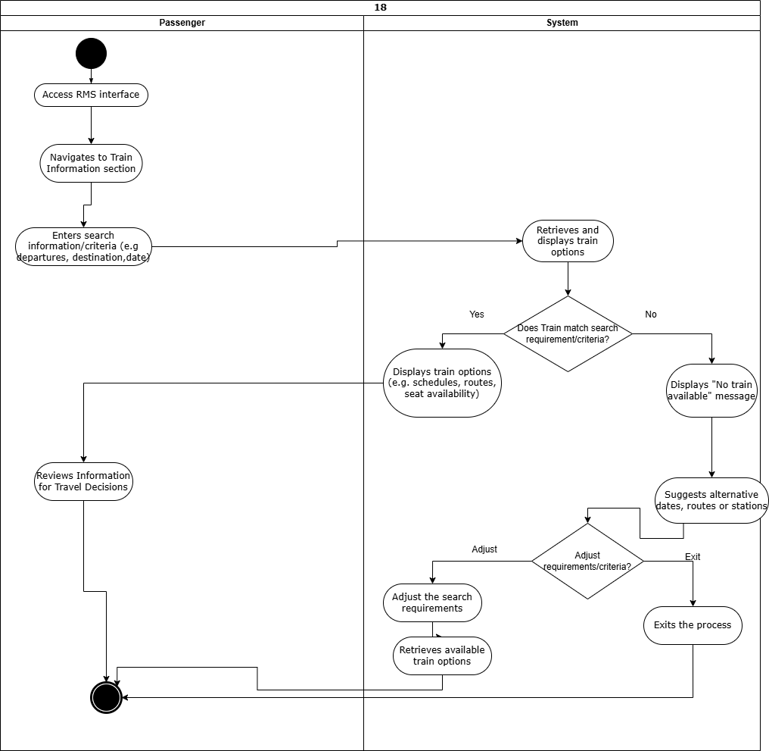

| UC Name | | ***P_TKT_19 - Passenger Cancels Reservation*** | | | | | | | |
| --- | --- | --- | --- | --- | --- | --- | --- | --- | --- |
| Summary | | Passengers that cancel their train reservation within a reasonable timeframe, ensuring flexibility in travel plans. | | | | | | | |
| Dependency | | * ***P_TKT_17*** *(Passenger booking tickets)* * ***S_PAY_20*** *(payment processing).* | | | | | | | |
| Actors | | * ***Primary Actor:*** *Passenger (P)* * ***Secondary Actor:*** *System (S)* | | | | | | | |
| Preconditions | | * *The Passenger has an active reservation in the system.* * *The cancellation request is made within the allowed timeframe (TBD).* * *The Passenger is logged into their account or has a reservation reference number.* | | | | | | | |
| Description of the Main Sequence | | * **1.** The Passenger navigates to the "My Reservations" section of the RMS interface. * **2**. The system verifies that the cancellation is within the allowed timeframe and displays refund details (if applicable). * **3:** The Passenger confirms the cancellation. * **4.** The system updates the reservation status, releases the seat, and processes any refund. | | | | | | | |
| Description of the Alternative Sequence | | * **1.** If the cancellation request is outside the allowed timeframe, the system displays a message indicating that cancellation is not possible. * **2:** The system offers alternative options (e.g., modifying the reservation if permitted). * **3:** The Passenger either adjusts their request or exits the process. | | | | | | | |
| Non functional requirements | | * **Performance:**Cancellation processing must complete within 4 seconds. * **Security:** Reservation data and payment refunds must be encrypted and logged securely. * **Usability:** The cancellation process must be straightforward with clear instructions. | | | | | | | |
| Postconditions | | * The Passenger’s reservation is canceled, and the seat is made available for other bookings. | | | | | | | |

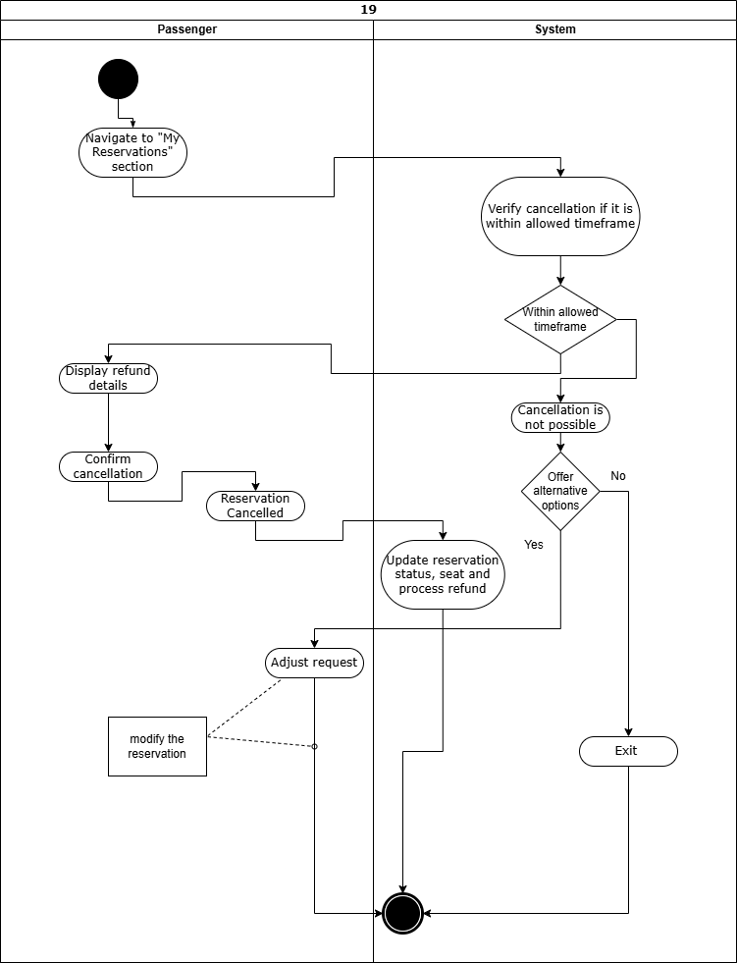

| UC Name | | ***S_PAY_20 – Process Ticket Payment*** | | | | | | | |
| --- | --- | --- | --- | --- | --- | --- | --- | --- | --- |
| Summary | | The system processes ticket payments made by passengers using card or cash at ticket booths to confirm bookings and issue valid tickets. | | | | | | | |
| Dependency | | * **P_TKT_17 – Book Ticket** (Payment is required to complete the booking). * **S_FIN_35 – Track Expenses and Profit** (Payments contribute to financial tracking). | | | | | | | |
| Actors | | * **Primary Actor:** **Passenger (P)** – Initiates the payment process. * **Secondary Actors:**   **System (S):** Verifies payment, processes the transaction, and confirms booking.  **Ticket Booth Operator (E)**  **Banking System (External):** Processes card transactions. | | | | | | | |
| Preconditions | | * The passenger has a valid ticket reservation.. * The system is connected to the payment processing service. | | | | | | | |
| Description of the Main Sequence | | * **1.** Passenger selects the preferred payment method (card or cash). * **2.** System calculates the total price and displays payment details. * **3.** Passenger proceeds with payment:   If paying by card: System redirects to the external banking system for transaction authorization.  If paying by cash: Ticket Booth Operator receives the cash and enters the amount into the system. System verifies the amount and confirms payment.   * **4.** System updates the booking status to "Paid." * **5.** System generates and issues the ticket (digital or printed) * **6.** System logs the transaction for financial tracking. | | | | | | | |
| Description of the Alternative Sequence | | * **1.If card payment fails:** System notifies the passenger and prompts them to retry or choose another payment method. * **2.If insufficient cash is provided:** Ticket Booth Operator requests the correct amount before proceeding. * **3.If system is down:** Manual override is used for cash transactions, with records updated later. | | | | | | | |
| Non functional requirements | | * **Performance:** Transaction processing should take no more than **5 seconds** for card payments. * **Security:** Card payments must be **secure and encrypted** to protect passenger information. * **Reliability:** System should have **99.9% uptime** for payment processing | | | | | | | |
| Postconditions | | * The passenger receives a valid ticket upon successful payment. * The system updates booking records and logs the transaction. * Failed payments trigger appropriate error messages and retries. | | | | | | | |

***UC 20: S_PAY_20 – Process Ticket Payment***

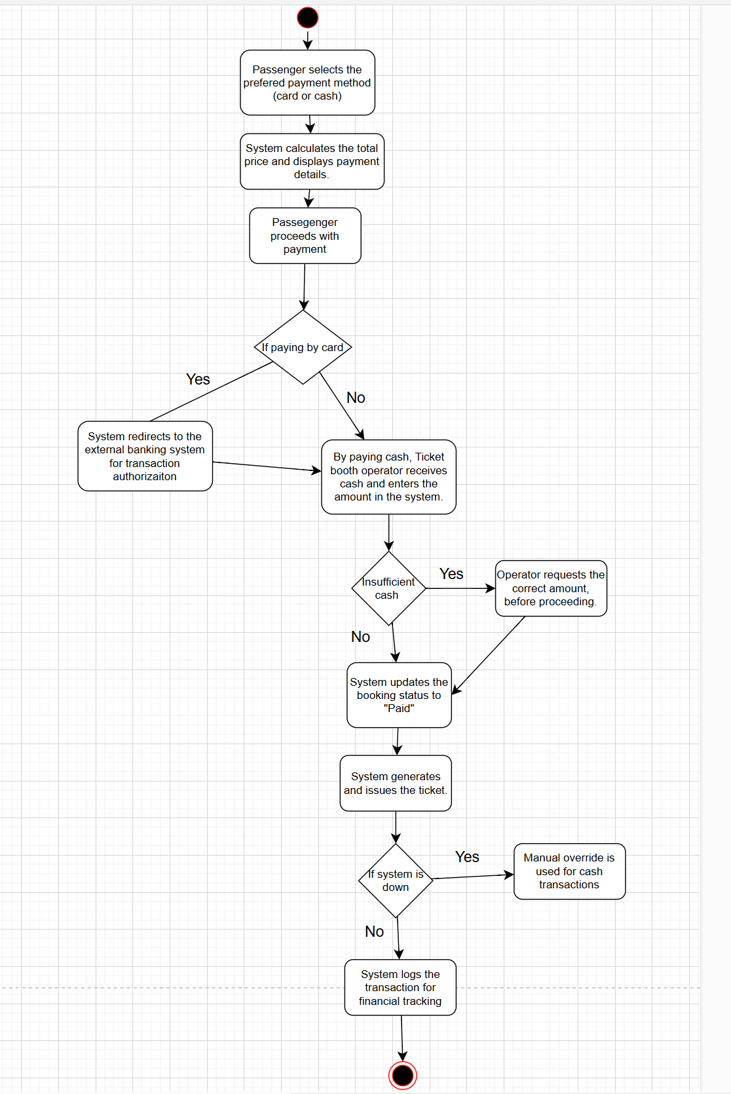

| UC Name | | ***S_NOT_21 - System Notifies Users of Timetable Changes*** | | | | | | | |
| --- | --- | --- | --- | --- | --- | --- | --- | --- | --- |
| Summary | | Details on how the system notifies all relevant users (e.g., Passengers, Traffic Managers, Station Managers) about changes in the train timetable based on their jurisdiction. | | | | | | | |
| Dependency | | * ***S_SCH_06*** *(system maintaining updated train schedules).* | | | | | | | |
| Actors | | * **Primary Actor**: System (S) * **Secondary Actor**: User (U) - includes Passengers (P), Traffic Managers (TM), Station Managers (SM) | | | | | | | |
| Preconditions | | * A change in the train timetable (e.g., delay, cancellation) has been recorded in the system. * Users have provided contact preferences (e.g., email, SMS, in-app notifications). * User jurisdiction data is up-to-date. | | | | | | | |
| Description of the Main Sequence | | * **1**. The system detects a timetable change (e.g., a delay or cancellation). * **2.** The system identifies all affected users based on their jurisdiction or booked tickets. * **3.** The system generates a notification with details of the change (e.g., new time, reason). * **4.** The system sends the notification to affected users via their preferred method. * **5.** Users receive and review the notification. | | | | | | | |
| Description of the Alternative Sequence | | * **1 .**  If a user’s contact information is invalid or missing, the system logs the failure to notify. * **2.** The system flags the issue for administrative review. * **3.** The notification is made available in the user’s account interface as a fallback. | | | | | | | |
| Non functional requirements | | * ***Performance:*** *Notifications must be sent within 1 minute of the timetable change.* * ***Reliability:*** *The system must ensure high delivery success for notifications.* * ***Security:*** *Notification data must be encrypted in transit (SSL/TLS).* | | | | | | | |
| Postconditions | | * All relevant users have been notified of the timetable change. | | | | | | | |

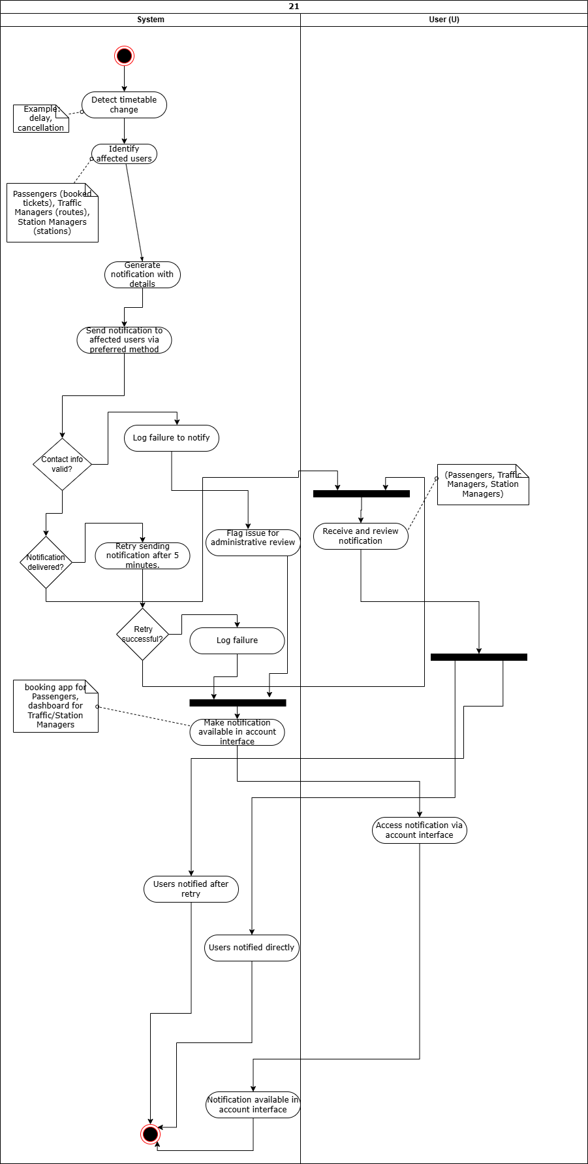

| UC Name | | ***S_NOT_22 - System Notifies External Maintenance of Scheduled Checks*** | | | | | | | |
| --- | --- | --- | --- | --- | --- | --- | --- | --- | --- |
| Summary | | How the system notifies External Maintenance personnel about scheduled maintenance checks for trains, tracks, or stations. | | | | | | | |
| Dependency | | * ***S_TRK_05*** *(train car availability and condition)* * ***S_SCH_06*** *(scheduling).* | | | | | | | |
| Actors | | * **Primary Actor**: System (S) * **Secondary Actor**: Traffic Manager (TM) | | | | | | | |
| Preconditions | | * A maintenance check has been scheduled in the system. * Contact information for External Maintenance personnel is available. * The system has up-to-date maintenance schedules. | | | | | | | |
| Description of the Main Sequence | | * **1**. The system identifies a scheduled maintenance check approaching its due time. * **2.** The system compiles details of the maintenance task (e.g., location, equipment, time). * **3.** The system sends a notification to the designated External Maintenance team via email, SMS, or system alert. * **4.** External Maintenance personnel receive and acknowledge the notification. | | | | | | | |
| Description of the Alternative Sequence | | * **1 .**  If the External Maintenance team is unavailable or contact fails, the system escalates the notification to a backup contact or supervisor. * **2.** The system logs the initial failure for review. * **3.** The backup contact receives the notification and acknowledges the notification | | | | | | | |
| Non functional requirements | | * ***Performance:*** *Notifications must be sent at least 24 hours before the scheduled maintenance, with real-time delivery within 1 minute of generation.* * ***Security:*** *Maintenance schedules and notifications must be encrypted.* * ***Reliability:*** *The system must ensure high notification delivery for critical maintenance tasks.* | | | | | | | |
| Postconditions | | * External Maintenance personnel (or their backup contact) have been notified and acknowledged the scheduled maintenance check. | | | | | | | |

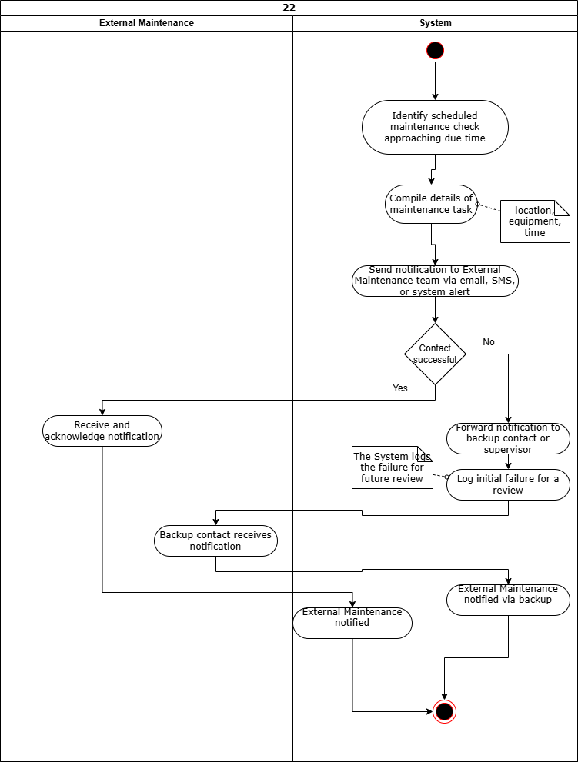

| UC Name | | ***E_WRK_23 – Employee Work Hour Logging*** | | | | | | | |
| --- | --- | --- | --- | --- | --- | --- | --- | --- | --- |
| Summary | | Employees must be able to log their working hours into the system for accurate record-keeping and payroll processing. | | | | | | | |
| Dependency | | **• FIN_01** (Financial Tracking & Reporting) → Logged work hours must be recorded for payroll calculations. | | | | | | | |
| Actors | | * **• Primary Actor: Employee (E)** * **• Secondary Actor: System (S)** | | | | | | | |
| Preconditions | | ➔ The employee must have valid system access.➔ The system must be available for logging hours. | | | | | | | |
| Description of the Main Sequence | | * • Step 1: The employee logs into the system. * • Step 2: The employee navigates to the work hour logging section. * • Step 3: The employee checks in work start and end times. * • Step 4: The system validates and records the logged hours. * • Step 5: The system confirms the logging and updates employee records. | | | | | | | |
| Description of the Alternative Sequence | | * • Step 1: If the system is down, employees receive a notification to log hours later. | | | | | | | |
| Non functional requirements | | **➔ Usability:** The interface must be user-friendly and accessible.    **➔ Data Accuracy:** Logged hours must be correctly recorded and stored securely. | | | | | | | |
| Postconditions | | * • Employee work hours are successfully recorded in the system. | | | | | | | |

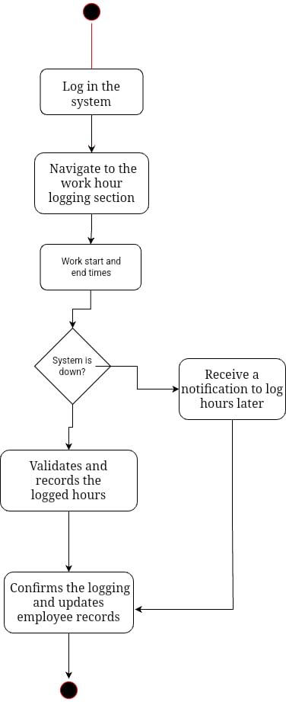

| UC Name | | **E_WRK_24 – Employee Task Checking** | | | | | | | |
| --- | --- | --- | --- | --- | --- | --- | --- | --- | --- |
| Summary | | Employees must be able to check specific tasks assigned to them by the Station Manager. | | | | | | | |
| Dependency | | **• SM_WRK_25 (Station Managers Assign Tasks) → Tasks must be assigned before employees can check them.** | | | | | | | |
| Actors | | * **• Primary Actor: Employee (E)• Secondary Actor: System (S)** | | | | | | | |
| Preconditions | | *➔ The employee must have valid credentials to access the system.*  *➔ The Station Manager must have assigned tasks to employees.* | | | | | | | |
| Description of the Main Sequence | | * • Step 1: The employee logs into the system. * • Step 2: The employee navigates to the task list section. * • Step 3: The system displays assigned tasks. * • Step 4: The employee reviews task details (e.g., deadline, priority). * • Step 5: The employee acknowledges receipt of the task. | | | | | | | |
| Description of the Alternative Sequence | | * • Step 1: If no tasks are assigned, the system notifies the employee. * • Step 2: If the system is down, the employee receives an error message and is prompted to try later. | | | | | | | |
| Non functional requirements | | **➔ Responsiveness: Task lists must load quickly.**  **➔ Security: Only authorized employees can access their tasks.** | | | | | | | |
| Postconditions | | * • The employee is aware of assigned tasks. | | | | | | | |

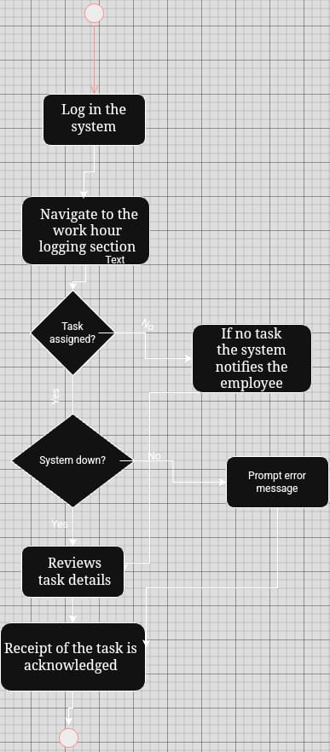

| UC Name | | **SM_WRK_25 – Station Manager Assigns Tasks to Employees** | | | | | | | |
| --- | --- | --- | --- | --- | --- | --- | --- | --- | --- |
| Summary | | Station Managers must be able to send specific tasks to employees via the system to ensure smooth operations. | | | | | | | |
| Dependency | | **• E_WRK_24 (Employee Task Checking) → Employees must be able to check assigned tasks.** | | | | | | | |
| Actors | | * **• Primary Actor: Station Manager (SM)• Secondary Actor: System (S)** | | | | | | | |
| Preconditions | | *➔ The Station Manager must have valid credentials.*  *➔ Employees must be registered in the system.* | | | | | | | |
| Description of the Main Sequence | | * • Step 1: The Station Manager logs into the system. * • Step 2: The Station Manager selects an employee to assign a task. * • Step 3: The Station Manager enters task details (description, deadline, priority). * • Step 4: The system records the task and notifies the employee. * • Step 5: The employee acknowledges receipt of the task. | | | | | | | |
| Description of the Alternative Sequence | | * • Step 1: If the selected employee is unavailable, the system suggests an alternative employee. * • Step 2: If the system fails to send the task notification, the Station Manager is alerted. | | | | | | | |
| Non functional requirements | | **➔ Efficiency: Task assignments must be processed in real time**  **.➔ Auditability: The system must track task assignments for accountability.** | | | | | | | |
| Postconditions | | * • The task is successfully assigned and recorded. | | | | | | | |

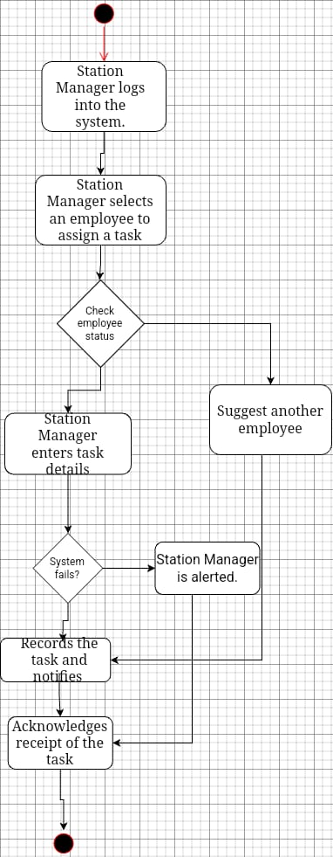

| UC Name | **S_ALR_27 – Detect Alert Sensors in Railways, Trains, and Stations** |
| --- | --- |
| Summary | All users must be able to see their personal information |
| Dependency | **S_SAF_12** (Railway Safety Monitoring) → Alerts must be detected for safety measures.  **S_MNT_09** (Maintenance Alert System) → Alerts must trigger maintenance actions if needed. |
| Actors | • **Primary Actor:** System (S)  • **Secondary Actor:** Station Manager (SM), Employee (WRK) |
| Preconditions | ➜ The system must be connected to all relevant alert sensors.  ➜ The Station Manager and Employees must have appropriate access rights. |
| Description of the Main Sequence | 1. The system continuously scans for alert signals from sensors.  2. When an alert is detected, the system logs the event.  3. The system categorizes the alert based on severity and type.  4. The Station Manager is notified immediately.  5. If required, the system triggers automated safety or maintenance actions. |
| Description of the Alternative Sequence | 1. If an alert sensor fails, the system sends a diagnostic request.  2. If the system cannot categorize an alert, it escalates the issue to the Station Manager. |
| Non-functional Requirements | ➜ **Real-time Alerts:** Alerts must be detected and reported immediately.  ➜ **Reliability:** The system must operate continuously without failure.  ➜ **Security:** Only authorized personnel can access or modify alert settings.  ➜ **Audit Logging:** All detected alerts and responses must be logged |
| Postconditions | ✓ The system maintains an up-to-date record of all detected alerts.  ✓ The system ensures safety by promptly notifying responsible personnel and triggering automated responses when necessary. |

| UC Name | **M_ALR_29 – Managers Can Initiate Alerts** |
| --- | --- |
| Summary | Managers must have the ability to manually trigger alerts based on situational assessments to ensure proactive safety measures and operational control. |
| Dependency | • **S_ALR_27** (Detect Alert Sensors) → Alerts must be detected automatically when applicable. • **S_COM_05** (Communication Module) → Notifications must be delivered to the correct recipients. |
| Actors | **Primary Actor:** Manager (M) • **Secondary Actor:** System (S), Station Manager (SM), Maintenance Staff (WRK), Emergency Responders |
| Preconditions | ➜ The manager must have appropriate access rights. ➜ The system must provide an interface for manual alert initiation. |
| Description of the Main Sequence | 1. The manager assesses the situation and decides to trigger an alert. 2. The manager selects the appropriate alert type and severity. 3. The system verifies the manager's authorization. 4. The system sends notifications via the appropriate communication channels. 5. The system logs the manually triggered alert and its responses. |
| Description of the Alternative Sequence | 1. If the manager lacks proper authorization, the system denies the request and logs the attempt. 2. If the alert fails to be sent, the system retries using an alternative method (e.g., backup server) |
| Non-functional Requirements | ➜ **Real-time Execution:** Manually triggered alerts must be processed immediately. ➜ **Reliability:** The system must ensure all alerts reach the intended recipients. ➜ **Security:** Only authorized managers should be able to initiate alerts. ➜ **Audit Logging:** All manually triggered alerts and actions must be recorded for accountability |
| Postconditions | ✓ The system ensures that manager-initiated alerts are delivered to the appropriate users. ✓ The system maintains a log of all manual alert triggers for review and compliance. |

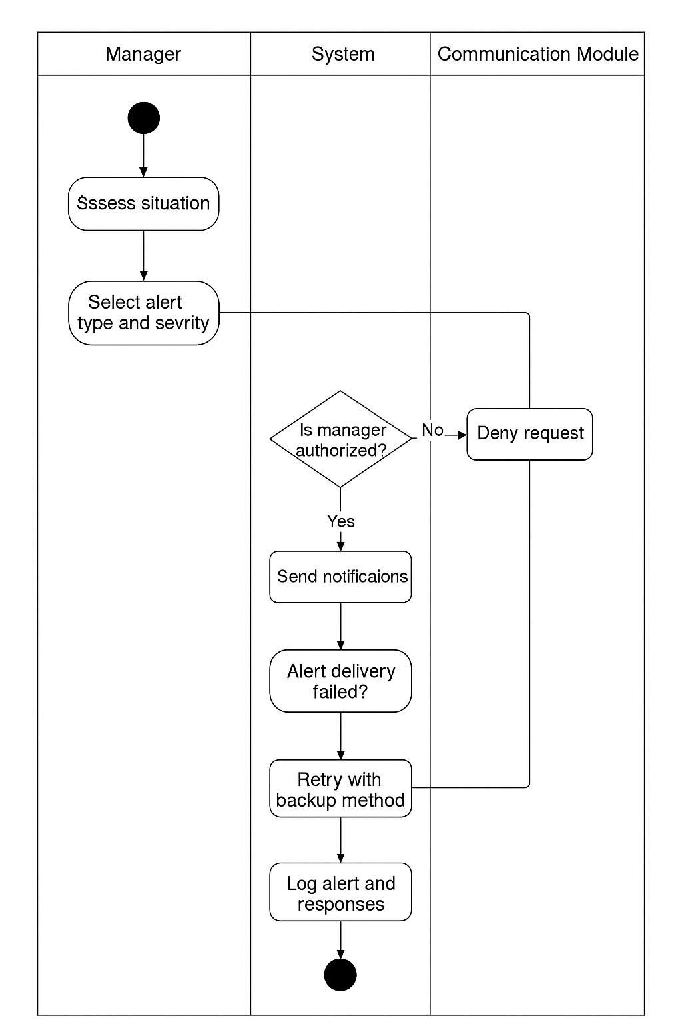

| UC Name | | ***S_ALR_28 – Notify Users for Specific Alerts*** | | | | | | | |
| --- | --- | --- | --- | --- | --- | --- | --- | --- | --- |
| Summary | | The system detects an alert and notifies the appropriate user(s) based on the alert type and their role. | | | | | | | |
| Dependency | | * ***S_ALR_27 – Detect Alert Sensors*** *(Alerts must be detected first).* | | | | | | | |
| Actors | | * ***Primary Actor:******System (S)*** *– Identifies alerts and sends notifications.* * ***Secondary Actors****: Traffic Manager (TM) , Station Manager (SM),*   *Employees (E) , Passengers (P) , Managers (M)* | | | | | | | |
| Preconditions | | * Alert detection mechanisms are active and functional. * User contact information (email, SMS, app notifications) is configured in the system. * Users have the necessary permissions to receive alerts. | | | | | | | |
| Description of the Main Sequence | | * **1.** An alert is triggered by a system event (e.g., track obstruction, train delay, safety breach). * **2.** System identifies the nature of the alert. * **3.** System determines the appropriate recipient(s) based on the alert type. * **4.**System generates and sends notifications via SMS, email, app, or system dashboard. * **5.**Recipient acknowledges the alert (if required). * **6.**System logs the notification and any user response. | | | | | | | |
| Description of the Alternative Sequence | | * **1.If the notification system fails:** The system retries or uses an alternative notification method. * **2.If the designated user does not acknowledge the alert**: System escalates the alert to a higher authority. | | | | | | | |
| Non functional requirements | | * **Real-time Processing:** Alerts must be sent **within 5 seconds** of detection. * **Security:** Only authorized users should receive relevant alerts. * **Scalability:** The system should handle multiple alerts simultaneously. | | | | | | | |
| Postconditions | | * *The correct user(s) receive the alert notification.* * *The system logs the alert and any actions taken.* * *If required, the system escalates the issue to the next level.* | | | | | | | |

| UC Name | **P_SVC_30 – Passengers Can Request Accessibility Services** |
| --- | --- |
| Summary | Passengers must have the ability to request accessibility services, such as wheelchair assistance, priority seating, or other special accommodations, to ensure an inclusive travel experience. |
| Dependency | • **S_SCH_10** (Train Scheduling System) → The system must coordinate accessibility service requests with train schedules. • **S_COM_05** (Communication Module) → Notifications must be sent to the appropriate railway staff. |
| Actors | • **Primary Actor:** Passenger (P) • **Secondary Actor:** System (S), Station Manager (SM), Accessibility Service Staf |
| Preconditions | ➜ The passenger must have access to a service request interface (e.g., mobile app, kiosk, or ticket counter). ➜ The system must support real-time processing of accessibility requests. |
| Description of the Main Sequence | **Description of the Main Sequence** |
| Description of the Alternative Sequence | 1. If no service staff is available, the system provides an estimated time for assistance. 2. If the request cannot be fulfilled, the system informs the passenger and suggests alternatives. |
| Non-functional Requirements | ➜ **Real-time Processing:** Requests must be handled immediately. ➜ **Reliability:** The system must ensure all requests are processed correctly. ➜ **Security:** Passenger data must be protected. ➜ **Audit Logging:** All service requests and responses must be recorded |
| Postconditions | ✓ The system ensures that accessibility service requests are assigned and fulfilled. ✓ The system maintains a log of all accessibility service requests for monitoring and improvement. |

| UC Name | **P_TKT_31 – Passengers Can Opt into Loyalty Programs or Alternate Payment Methods** |
| --- | --- |
| Summary | Passengers must have the ability to enroll in loyalty programs and use alternate payment methods for ticketing, ensuring flexibility and rewards for frequent travelers. |
| Dependency | • **S_TKT_12** (Ticketing System) → The system must integrate loyalty programs and multiple payment options. • **S_COM_05** (Communication Module) → Notifications regarding loyalty points and payment confirmations must be sent. |
| Actors | • **Primary Actor:** Passenger (P) • **Secondary Actor:** System (S), Ticketing Manager (TKT), Financial Service Providers |
| Preconditions | ➜ The passenger must have access to a booking interface (e.g., mobile app, website, ticket counter). ➜ The system must support various payment methods and loyalty program registration. |
| Description of the Main Sequence | 1. The passenger selects a ticket for booking. 2. The system offers loyalty program enrollment and alternative payment methods. 3. The passenger chooses to enroll in a loyalty program or selects a preferred payment method. 4. The system processes the selection and updates the passenger's profile. 5. The system confirms the transaction and sends a notification. |
| Description of the Alternative Sequence | 1. If the selected payment method fails, the system prompts the passenger to choose another method. 2. If the passenger is already enrolled in a loyalty program, the system applies available rewards automatically. |
| Non-functional Requirements | ➜ **Real-time Processing:** Enrollment and payments must be handled instantly. ➜ **Reliability:** The system must ensure successful processing of all transactions. ➜ **Security:** Payment and personal data must be protected. ➜ **Audit Logging:** All transactions and enrollments must be recorded. |
| Postconditions | ✓ The system ensures that accessibility service requests are assigned and fulfilled. ✓ The system maintains a log of all accessibility service requests for monitoring and improvement. |

| UC Name | S_CAP_32 |
| --- | --- |
| Summary | System must observe train capacity to eliminate overbooking |
| Dependency | S_TRK_03  S_TRK_05 |
| Actors | Passenger, System |
| Preconditions | The train capacity data must be available. |
| Description of the Main Sequence | 1. System retrieves real-time train capacity data. 2. System checks passenger bookings against available capacity. 3. If capacity is exceeded, system prevents further bookings. 4. If capacity allows, booking is confirmed. |
| Description of the Alternative Sequence | If system fails to retrieve train capacity, an error message is displayed. |
| Non functional requirements | * System must update capacity in real time. * System must handle multiple concurrent booking requests. |
| Postconditions | The train booking system reflects updated capacity status. |

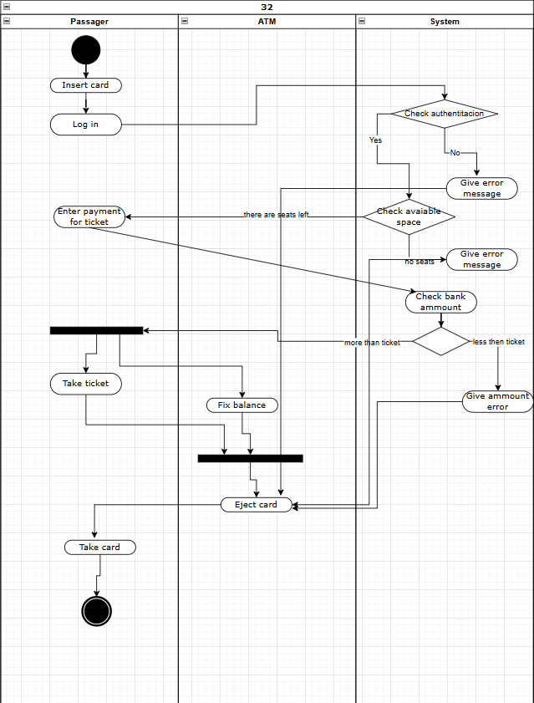

| UC Name | SM_ALR_33 |
| --- | --- |
| Summary | Station Managers are allowed to alert passengers to any of their alerts |
| Dependency | TM_MNG_01  S_TRK_05  S_ALR_27  S_ALR_28 |
| Actors | Station Manager, Passenger, System |
| Preconditions | Station Manager must be logged in. |
| Description of the Main Sequence | 1. Station Manager accesses the alert system. 2. Station Manager selects or inputs an alert message. 3. System sends alert notification to relevant passengers. |
| Description of the Alternative Sequence | If system cannot send alert, an error message is displayed. |
| Non functional requirements | * System must deliver alerts in real time. * System must ensure alert visibility to passengers. |
| Postconditions | Passengers receive alerts from the station manager. |

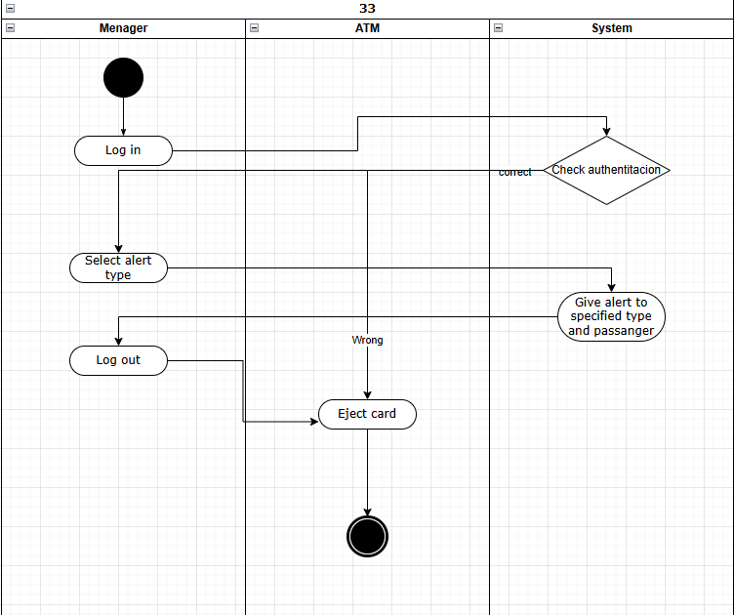

| UC Name | U_AUTH_34 |
| --- | --- |
| Summary | All users must have login logout functionality |
| Dependency | U_VIW_26 |
| Actors | All Users, System |
| Preconditions | User must have valid credentials. |
| Description of the Main Sequence | 1. User enters login credentials. 2. System verifies credentials. 3. If valid, user is granted access. |
| Description of the Alternative Sequence | If credentials are invalid, an error message is displayed. |
| Non functional requirements | * System must securely store user credentials. * Authentication should be completed within 3 seconds. |
| Postconditions | User is successfully logged in or out. |

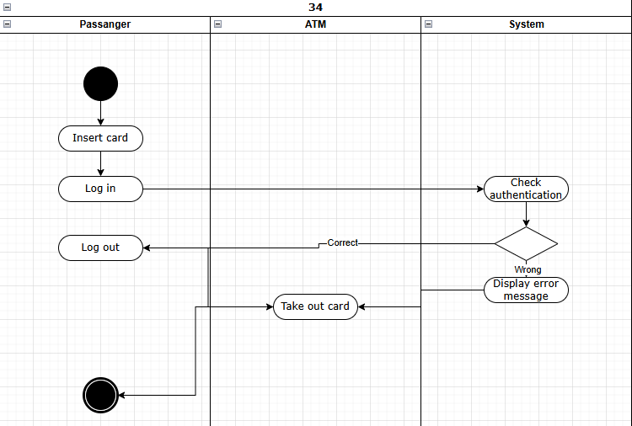

| UC Name | S_FIN_35 |
| --- | --- |
| Summary | The system must keep track of expenses and profit. |
| Dependency | S_PER_08  P_TKT_31 |
| Actors | System, Admin |
| Preconditions | Financial data must be available. |
| Description of the Main Sequence | 1. System collects financial data from transactions. 2. System generates reports on revenue and expenses. |
| Description of the Alternative Sequence | If system cannot fetch data, an error message is displayed. |
| Non functional requirements | * System must ensure data integrity. * Financial reports must be generated within 10 seconds. |
| Postconditions | Revenue and expense data is updated in the system. |

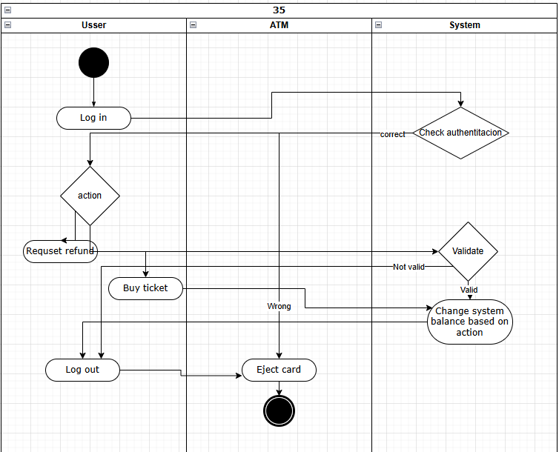

| UC Name | SM_FIN_36 |
| --- | --- |
| Summary | Station Managers are able to check station revenue and expenses |
| Dependency | S_FIN_35 |
| Actors | Station Manager, System |
| Preconditions | Station Manager must be logged in. |
| Description of the Main Sequence | 1. Station Manager requests financial report. 2. System retrieves and displays relevant financial data. |
| Description of the Alternative Sequence | If financial data is unavailable, an error message is displayed. |
| Non functional requirements | System must ensure financial data confidentiality. |
| Postconditions | Station Manager has access to financial data. |

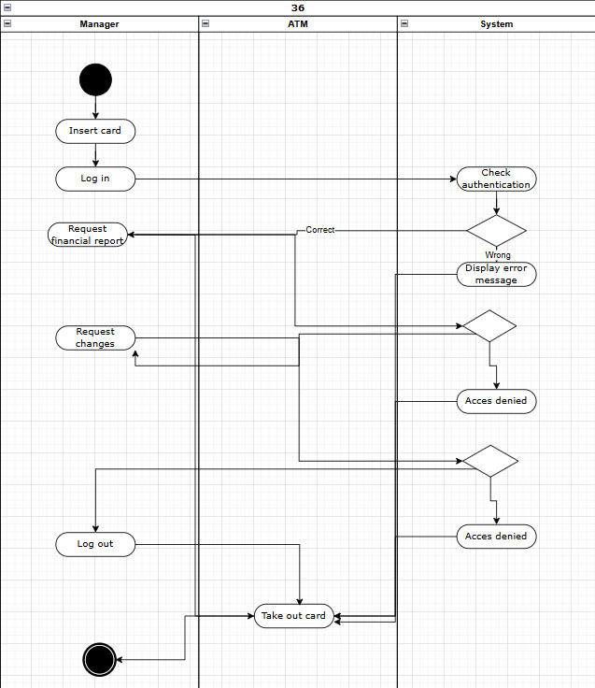

| UC Name | S_FIN_37 |
| --- | --- |
| Summary | The system must be able to generate detailed reports on revenue and expenses. |
| Dependency | S_FIN_35 |
| Actors | Admin, System |
| Preconditions | Financial data must be available. |
| Description of the Main Sequence | 1. Admin requests a financial report. 2. System compiles revenue and expense data. 3. System generates a detailed report. |
| Description of the Alternative Sequence | If report generation fails, an error message is displayed. |
| Non functional requirements | Reports must be generated within 10 seconds. |
| Postconditions | The financial report is available for review. |

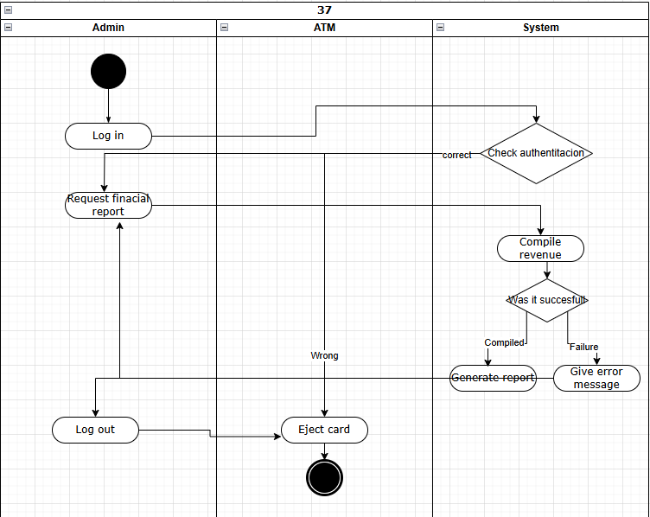

| UC Name | S_LOG_38 |
| --- | --- |
| Summary | The system must keep track of all operations done in a specified timeframe |
| Dependency | S_FIN_35 |
| Actors | System, Admin |
| Preconditions | System must have access to operation logs. |
| Description of the Main Sequence | 1. System records all operations performed. 2. System organizes and stores the log data. 3. Admin can retrieve and review the logs. |
| Description of the Alternative Sequence | If log retrieval fails, an error message is displayed. |
| Non functional requirements | * System must ensure log integrity and security. * Logs must be retrievable within 5 seconds. |
| Postconditions | Operations are recorded and available for audit. |

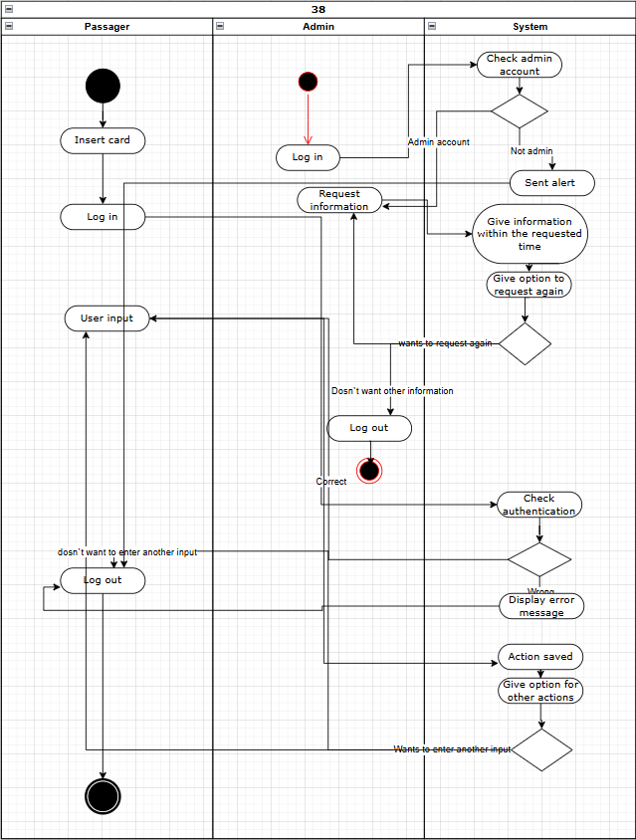

| UC Name | S_SCH_39 |
| --- | --- |
| Summary | The system must keep track of the schedule of everything within a specific timeframe |
| Dependency | TM_MNG_01  S_INT_02  S_TRK_03  S_TRK_04  S_TRK_05  S_SCH_06 |
| Actors | System, Admin |
| Preconditions | Schedule data must be available. |
| Description of the Main Sequence | 1. System retrieves the schedule. 2. System updates schedule changes in real time. |
| Description of the Alternative Sequence | If system fails to retrieve schedule, an error message is displayed. |
| Non functional requirements | System must ensure schedule accuracy. |
| Postconditions | Schedule data is up-to-date. |

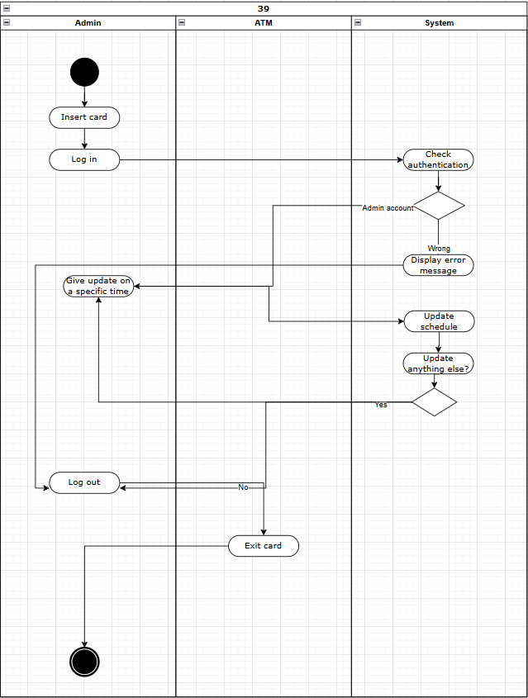

| UC Name | E_WRK_40 |
| --- | --- |
| Summary | Employees may request a shift change or time off |
| Dependency | S_SCH_39 |
| Actors | Employee, System |
| Preconditions | Employee must be logged in. |
| Description of the Main Sequence | 1. Employee submits a shift change request. 2. station manager processes request and updates schedule. 3. Alert employee of the status of their request. |
| Description of the Alternative Sequence | If request fails, an error message is displayed. |
| Non functional requirements | System must notify employees of request status. |
| Postconditions | Shift request is processed. |

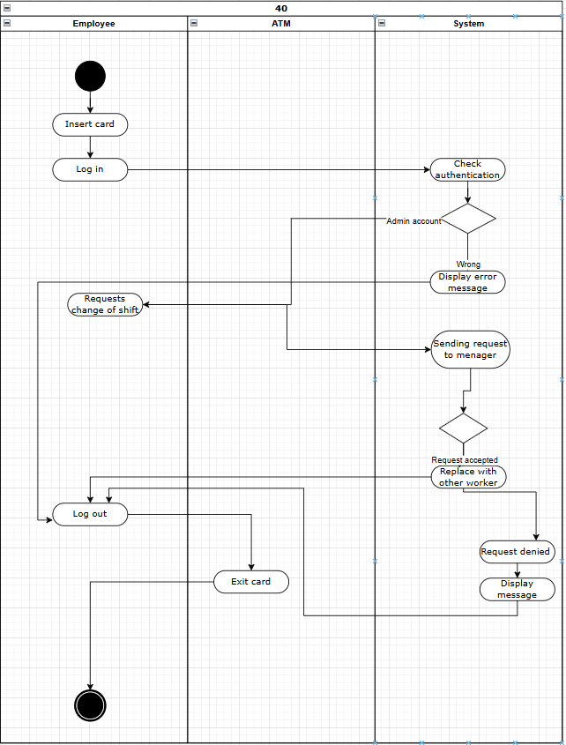

| UC Name | A_VIW_41 |
| --- | --- |
| Summary | An admin user is allowed to view all info on the system |
| Dependency | All |
| Actors | Admin, System |
| Preconditions | Admin must be logged in. |
| Description of the Main Sequence | 1. Admin accesses system overview. 2. System displays relevant data. |
| Description of the Alternative Sequence | System must ensure data confidentiality. |
| Non functional requirements | - |
| Postconditions | Admin successfully views system information. |

| UC Name | A_ADM_42 |
| --- | --- |
| Summary | An admin user is allowed to access all functionalities of the system, including other users |
| Dependency | All |
| Actors | Admin, System |
| Preconditions | Admin must be logged in. |
| Description of the Main Sequence | 1. Admin accesses system functionalities. 2. System grants access based on admin privileges. |
| Description of the Alternative Sequence | - |
| Non functional requirements | System must ensure security of admin actions. |
| Postconditions | Admin successfully manages system functionalities. |

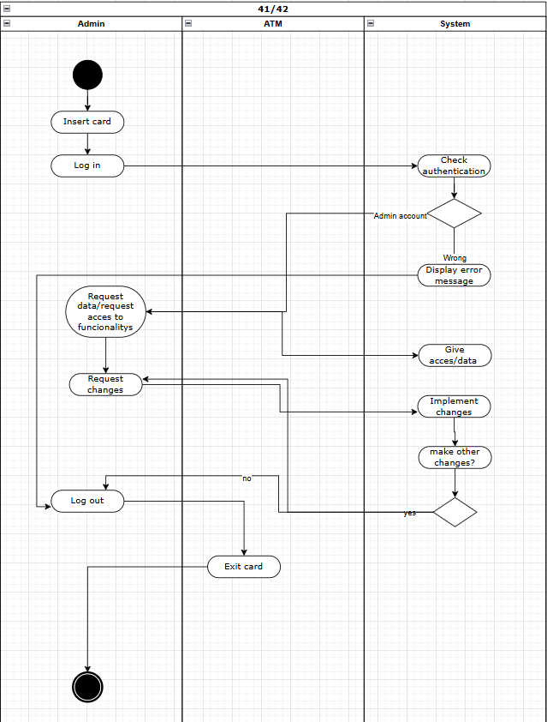

# 5. Diagrams

# 

In this section you are going to place all of the diagrams that you build throughout the course, in following with the slides presented throughout the weeks.

5.1 ER Diagram

Standard ERD for your project. Not much but the skills gained in the DBMS course are required.  
  
5.2 Use Case Diagram (general)

Use Case Diagram (only one, with all the use cases).

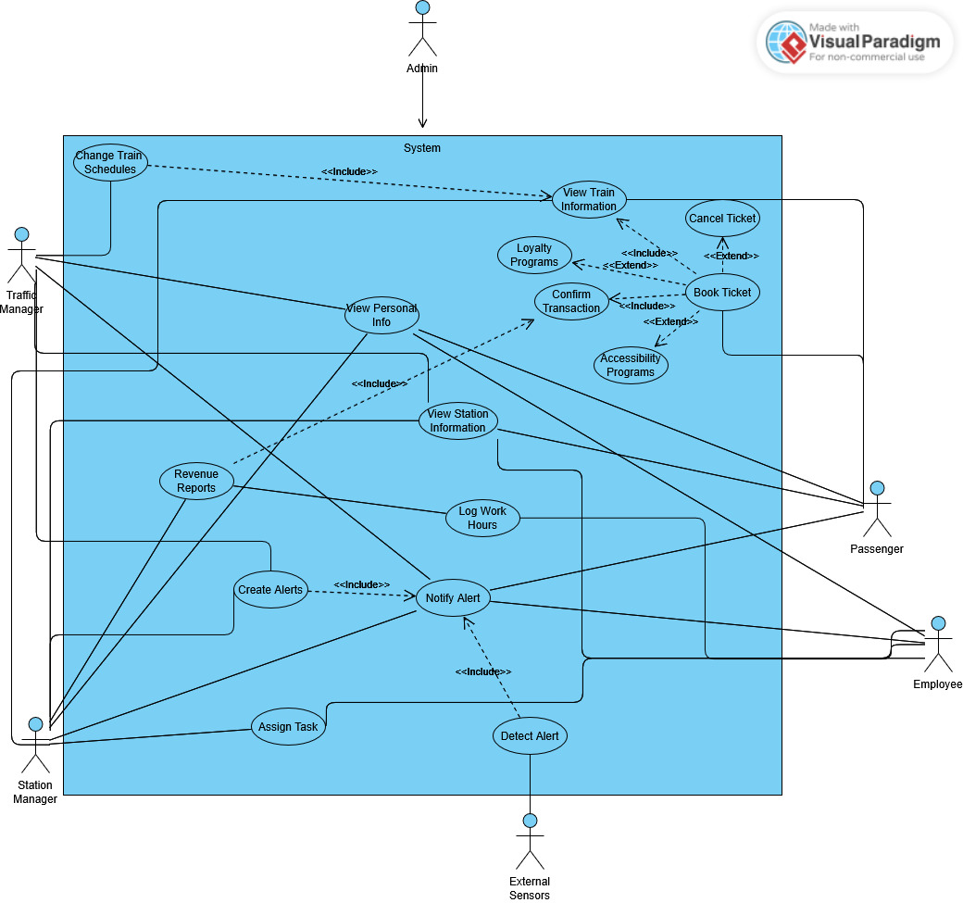

5.3 Activity Diagram

Each Activity Diagram should be associated with an use case, associated with a particular requirement which is further associated with a particular use-case. E.g BR_01 which becomes UC_01 which becomes AC_01.

5.4. Class diagram.

One class diagram (general) for all the classes. Edit it afterwards with the design pattern implemented in it.

5.5 State diagram

Place all the relevant state diagrams here.

5.6 Sequence diagram.

All sequence diagrams are associated with an Activity Diagram. A Sequence Diagram is built based on an activity diagram. If the activity diagram is named AC_07, the Sequence Diagram will be named SC_07.

5.7. Collaboration diagram

All collaboration diagrams directly relate to a sequence diagram. If a sequence diagram is named SC_07, then the collaboration diagram is named CC_07

# 6. Design Patterns

Choose the relevant design patterns for your project. For each, give a reasoning and the associated class and sequence diagram. These are NOT part of the above diagrams, and need not carry the following naming scheme.

# 7. Appendix.

# **Organizing the Requirements**

This section is for information only as an aid in preparing the requirements document.

Detailed requirements tend to be extensive. Give careful consideration to your organization scheme. Some examples of organization schemes are described below:

**By System Mode**

Some systems behave quite differently depending on the mode of operation. For example, a control system may have different sets of functions depending on its mode: training, normal, or emergency.

**By User Class**

Some systems provide different sets of functions to different classes of users. For example, an elevator control system presents different capabilities to passengers, maintenance workers, and fire fighters.

**By Objects**

Objects are real-world entities that have a counterpart within the system. For example, in a patient monitoring system, objects include patients, sensors, nurses, rooms, physicians, medicines, etc. Associated with each object is a set of attributes (of that object) and functions (performed by that object). These functions are also called services, methods, or processes. Note that sets of objects may share attributes and services. These are grouped together as classes.

**By Feature**

A feature is an externally desired service by the system that may require a sequence of inputs to affect the desired result. For example, in a telephone system, features include local call, call forwarding, and conference call. Each feature is generally described in a sequence of stimulus-response pairs, and may include validity checks on inputs, exact sequencing of operations, responses to abnormal situations, including error handling and recovery, effects of parameters, relationships of inputs to outputs, including input/output sequences and formulas for input to output.

**By Stimulus**

Some systems can be best organized by describing their functions in terms of stimuli. For example, the functions of an automatic aircraft landing system may be organized into sections for loss of power, wind shear, sudden change in roll, vertical velocity excessive, etc.

**By Response**

Some systems can be best organized by describing all the functions in support of the generation of a response. For example, the functions of a personnel system may be organized into sections corresponding to all functions associated with generating paychecks, all functions associated with generating a current list of employees, etc.

**By Functional Hierarchy**

When none of the above organizational schemes prove helpful, the overall functionality can be organized into a hierarchy of functions organized by common inputs, common outputs, or common internal data access. Data flow diagrams and data dictionaries can be used to show the relationships between and among the functions and data.

**Additional Comments**

Whenever a new Requirements Specification is contemplated, more than one of the organizational techniques given above may be appropriate. In such cases, organize the specific requirements for multiple hierarchies tailored to the specific needs of the system under specification.

There are many notations, methods, and automated support tools available to aid in the documentation of requirements. For the most part, their usefulness is a function of organization. For example, when organizing by mode, finite state machines or state charts may prove helpful; when organizing by object, object-oriented analysis may prove helpful; when organizing by feature, stimulus-response sequences may prove helpful; and when organizing by functional hierarchy, data flow diagrams and data dictionaries may prove helpful.